RPS Custom Keyboard Shortcuts
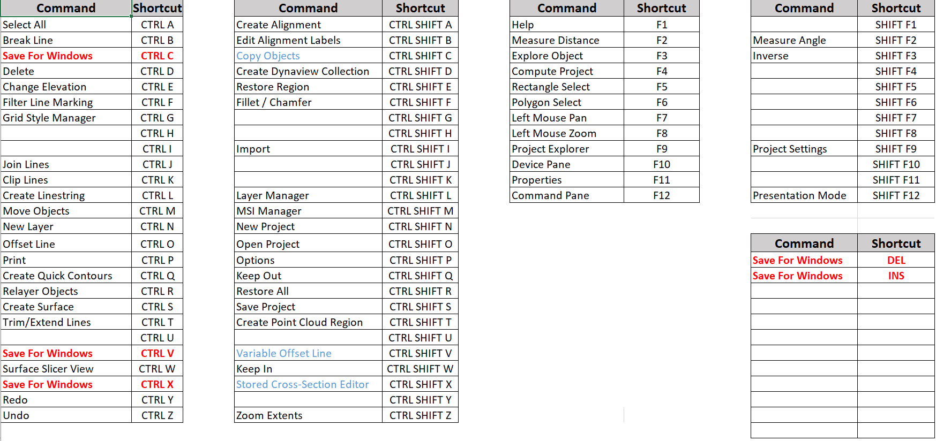

3D View / Plan View Mouse Controls
Forward / Reverse Wheel of Mouse | Zoom In and Out
Click Wheel of Mouse and Move | 3D Rotation
Right Click of Mouse | Pan
Left Click of Mouse and Drag | Select (note Top Left / Bottom Right (Inside) or Bottom Right to Top Left (Crossing) differences)
Left Click an Object | Select / Deselect
CTRL Click an Object | Incremental Select / Deselect
SHIFT Click Objects | Incremental Select / No Deselect
ALT Left Click | Center Rotation of 3D View – ALT Left Click white space to clear center
SHIFT when drawing a line | Ortho Snaps
CTRL SHIFT Wheel | Vertical Exaggerate the View (3D, Profile, Section, Slicer, Superelevation Views)

TBC User Interface
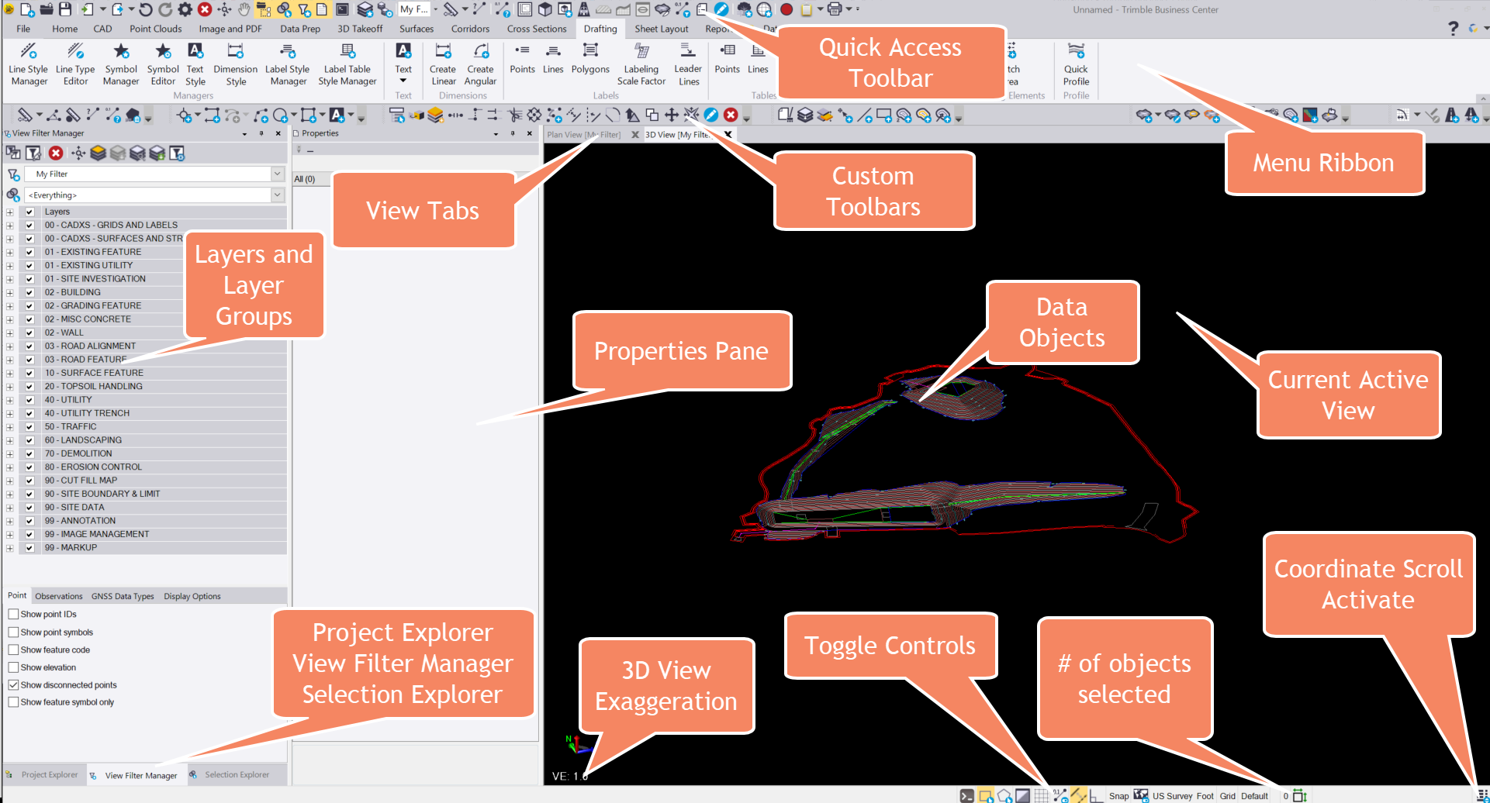

Useful Regular Expressions
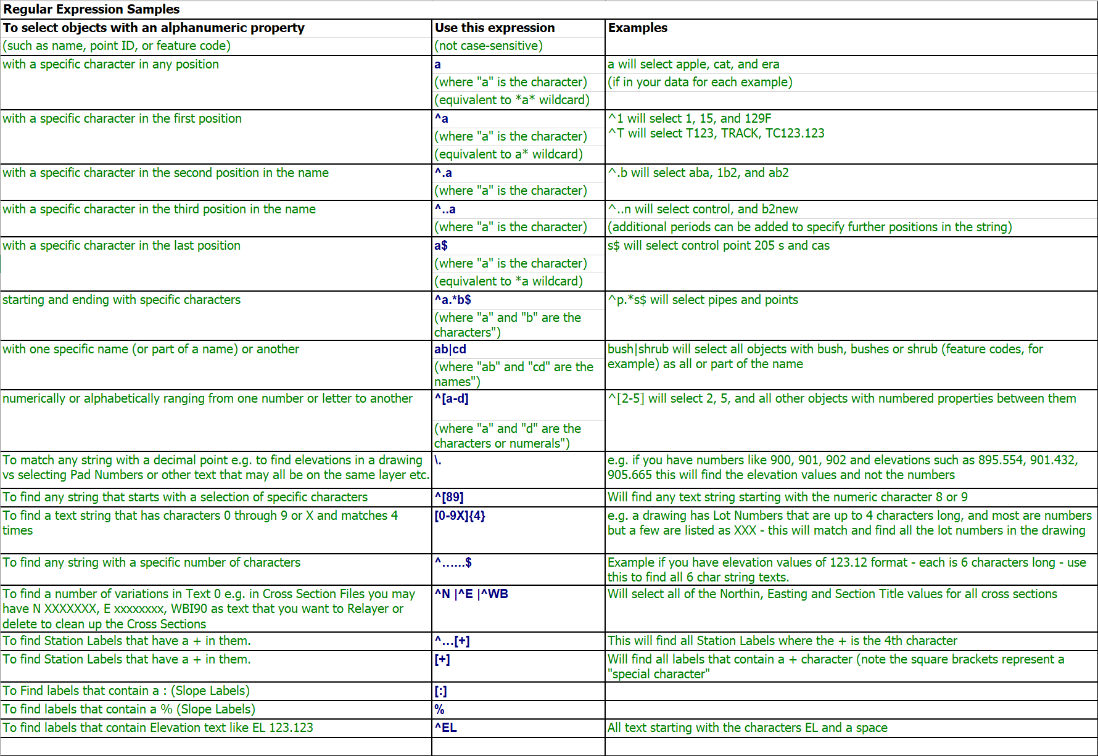

TBC Data Types and Structures
Project
- Project Template
- Project Settings
User Options
- Users unique settings and setups
Layer Groups
Layers and Layer Settings (By Layer)
CAD Objects
- Points
- CAD Lines
  - *Polyline (2D Object with optional one elevation)
  - *CAD Line (3D Object)
  - Boundary (2D Object, closed line, with optional one elevation)
  - *Polygon (3D Object, like a closed linestring)
  - *Circle (2D Object with optional one elevation)
  - *Rectangle (2D Object with optional one elevation)
  - *Ellipse (2D Object with optional one elevation)
  - *Arc (2D object with optional one elevation)
- TBC Lines
  - *Linestring (TBC 3D Line Object)
  - Alignment (Horizontal and Vertical Alignment Geometry, Superelevation and Station Equations)
  - Drape Lines (Dependent Objects on a surface and a source line)
- Blocks (3D objects)
- Hatch Patterns
- Text – Single Line or Multiline Text Objects with Smart Text Capabilty)

TBC Objects
- Surface Models
  - Normal Surfaces
  - Layer Surfaces (Created from groups of layers in Takeoff)
  - Strata Surfaces (Created from Borehole and Strata Settings)
  - Corridor Surfaces (Derived from Corridor Template Models)
  - Cut Fill Map / Isopach Surfaces (Difference Models (Dependent Objects)
  - Alignment Based Surfaces with / without Surface Densification
- Point Clouds
- Scans
- Images / PDF Page Images
- Corridor Models
- Sideslopes
- Surface Ties
- Vertical Designs
- Stored Cross Sections
- Surface Profiles
Drafting Objects
- Plotboxes
- Dynaviews (Similar to AutoCAD Viewports)
- Dynaview Grids
Styles
- Text Styles
- Label Styles
- Label Table Styles
- Dimension Styles
- Grid Styles
- Linestyles
Libraries
- Block Libraries
- Hatch Pattern Libraries
- Linestyle Libraries
- Symbol Libraries
- Materials and Site Improvement (MSI) Libraries
- Texture Libraries
Templates
- Project Templates
- Drafting Templates

