Technical Reference Document

Modeling Point Cloud Surfaces with Areas of Varying Point Densities

Overview
Modeling Large Surface Areas at the same point density extracted from Point Clouds will not necessarily give you the surface models that truly represent what you are trying to deliver. Most Projects will have areas where there are a lot of surface changes going on where you may want to model the surface with more data points per unit area and then areas e.g. Landscape Areas where modeling at a lower Point Density per unit area will suffice. The key to this is knowing where those High Density (HD) and Low Density (LD) areas are and delineating them with boundaries that can be used to create Low and High Density Point Cloud Regions.

Current Workflow Shortfalls
In the current release product, the only way to create a Point Cloud Region is to use the Polygon Select method to draw a polygon “freehand” to define an area that you want to make a Point Cloud Region. In a future release there will be a tool that allows you to select by pre-defined polygon. Until that release, you will need to create the polygon areas and then trace those areas out using the Polygon Select Tool to create the Point Cloud Regions.

Current Workflow Benefits
In the current release Point Cloud support, the number of points from the first Point Cloud region selected that will be used to create a surface is defined under Support – Options – Point Clouds. If you select e.g. 100,000 points as your setting then when you select one point cloud and create a surface from it, the surface will have 100,000 of the total number of points in the original point cloud added to the surface. If you then add a second Point Cloud Region to the Surface using Add / Remove Surface Members, then 100,000 points of that second point cloud region will be added to the initial 100,000 points from the first point Cloud Region.
Note: This approach only works this way when you add each point cloud individually to the surface created from the initial Point Cloud Region. If you select two point cloud regions to create your initial surface than you will only get a total of 100,000 points in the surface model, extracted from the two point cloud regions (the two point cloud regions are merged in background and 100,000 points extracted across the total point cloud region at a uniform density).
Note: If your first Point Cloud Region covers a Large Area and your Second Point Cloud Region covers a significantly smaller area, then the point density of the second area will be much higher because you will be extracting 100,000 points from a much smaller Point Cloud Region (in terms of number of points). This may in itself suffice to create a higher density surface in the HD area of the project.
Note: If between the addition of Point Cloud Region 1 and Point Cloud Region 2 you go to Support – Options – Point Clouds and change the Number of Points to include in a surface to e.g. 200,000 then when you add the second point cloud region to the surface using Add / remove Surface Members you will now add 200,000 points from the smaller HD Point Cloud Region to the surface – further increasing the point density of the surface model in that area. The Point Cloud settings are only applied when you add a point cloud / point cloud region to a surface model, once added the only way that you can change the density is to remove the point cloud region from the surface, change the setting and then re add the point cloud region back to the surface (thereby adding it at a higher point density.

Process Steps

- Import the Point Cloud Scan

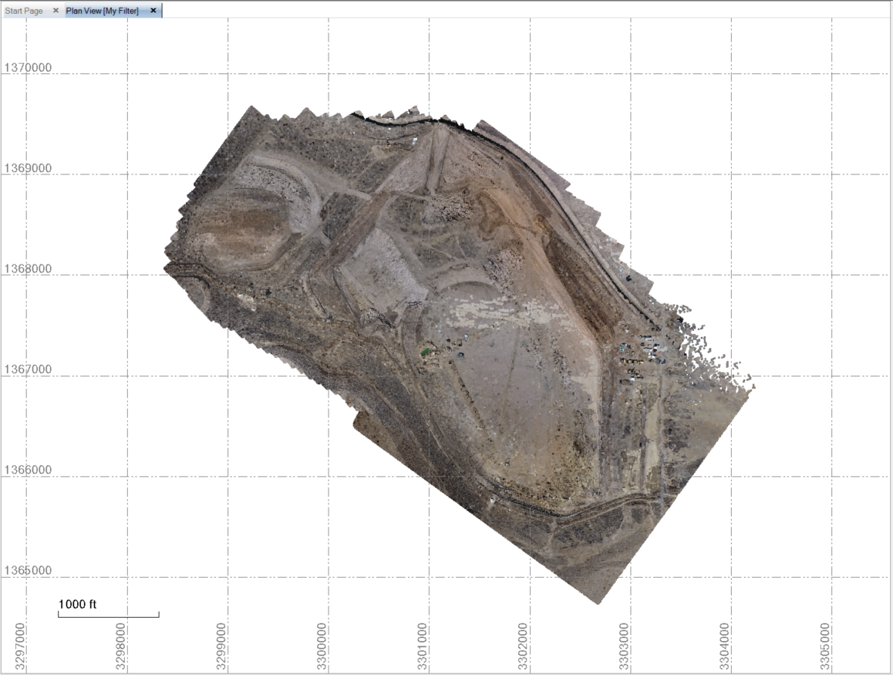

- Draw the polygon areas that you want to use at "Higher Density"

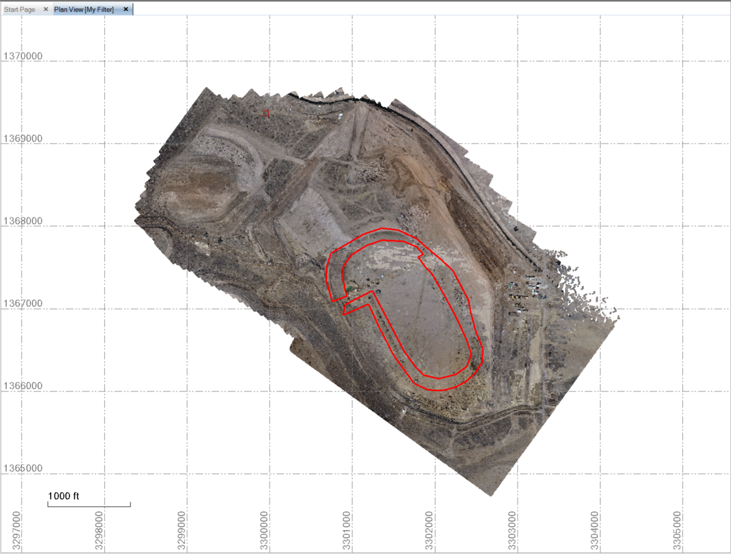

- Select the entire Point Cloud Scan and use it to create a Region called e.g. Feb 2018 - Low Density Areas
- Use Polygon Select and then trace out those areas that you drew as Polygons. This is less than ideal and will be addressed in a future release. In Polygon Select, Snaps do not currently work, so you can only approximate your desired polygon area. Use the selected areas of the Point Cloud to Create New Region(s) called Feb 2017 - High Density Area 1, 2, 3 etc.

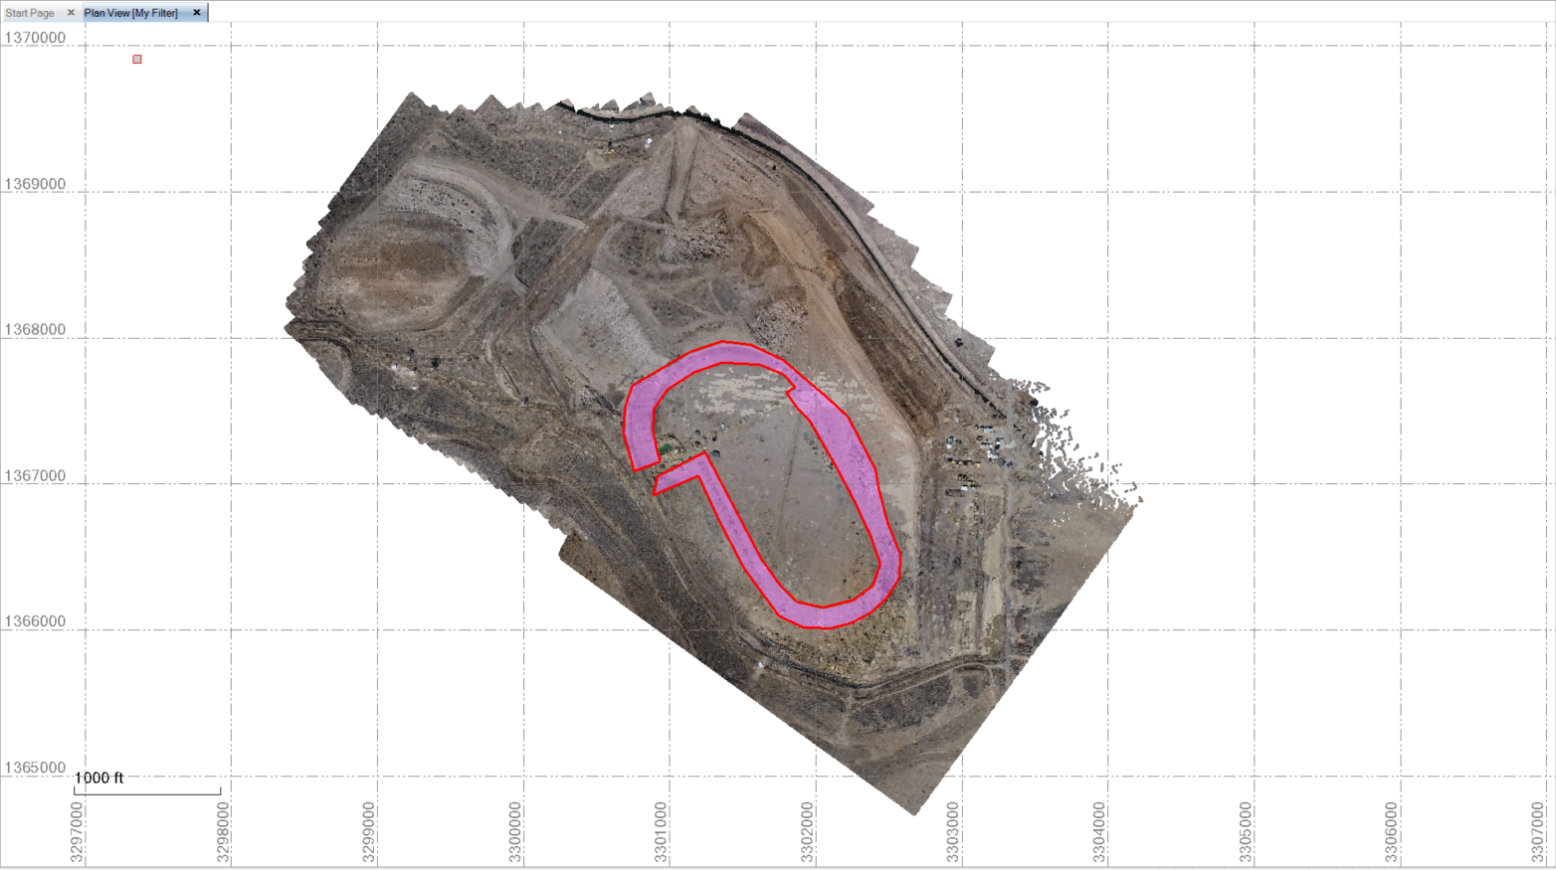
Highlighted Point Cloud Region Will Be High Density Area

- Set your Point Cloud Settings under Support - Options to allow the Point Cloud Surface to have e.g. 250000 points in it

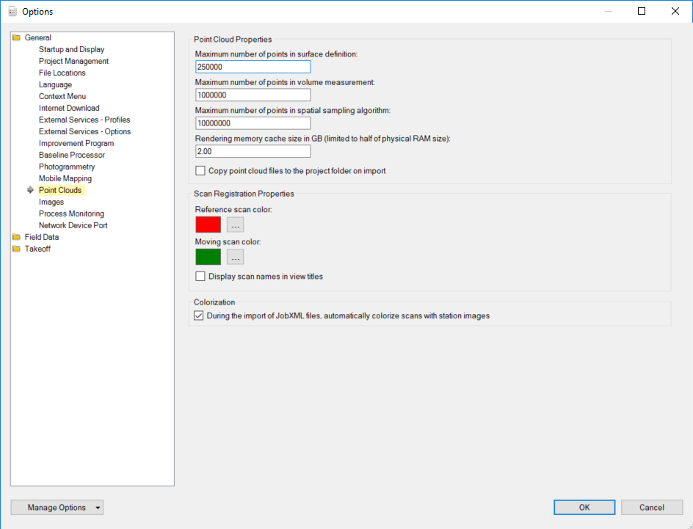

- Create a Surface Model from what is remaining of the Low Density point cloud (this will have holes in the surface that are filled across by triangles that we will later replace. In this step you will add 250,000 of the Low Density Point Cloud points to the surface model.

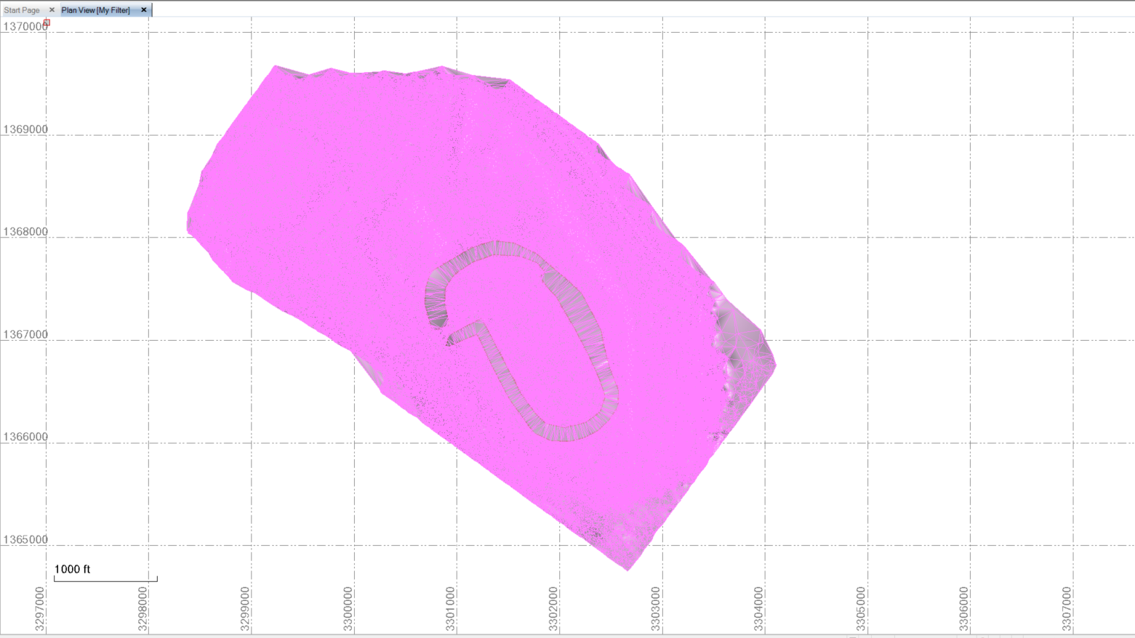
Note in the HD Area there are few triangles

- You can now if you want change the Point Cloud Option Settings to e.g. 500000 points so that when you add the HD point cloud regions to the surface you will use 500,000 of those point cloud region points to the 250,000 points that you added from the first point cloud region (making now 750,000 points in the surface model).
- Add the HD Point Cloud Region to the surface model using Add / Remove Surface Members

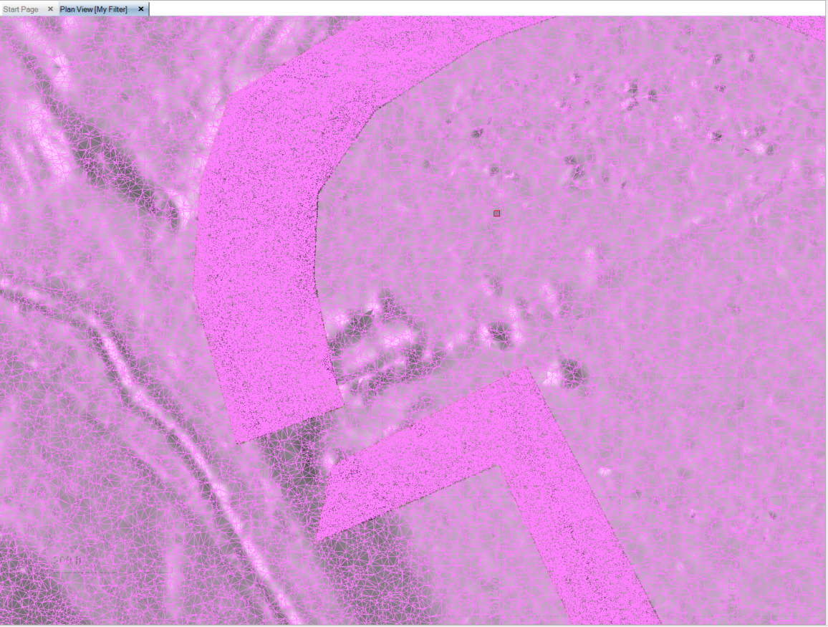
Note that the HD Area now has a much higher density of triangles

- You can add more Point Cloud Regions individually (one at a time) for the other HD areas to build out the composite model with varying densities as you see fit.

This process allows you to pick out areas of the job where you expect e.g. vertical or near vertical jumps in the data or where you have a lot of surface shape changes going on and model them at High Density and leaving the large landscape, less irregular or less critical areas at a lower density.
This is a tremendously powerful method to build out what you need for a model - it will be better still when the "Create Point Cloud Region by Boundary" command is available (saves having to trace out your polygon areas from flight to flight).

