Technical Reference Document

Improving Business Center – HCE Speed / Performance

File Size
We are sometimes asked about Business Center – HCE file size and why our file size appears large and how this could be mitigated. Below are some relevant points
File size on your hard disk when the project is in a closed state in itself is not an indicator that can be used to compare e.g. a Business Center – HCE project with a file for use with another product e.g. AutoCAD, Carlson, Agtek or Insite etc. All products manage data in different ways e.g.
- Compressed when closed vs uncompressed – some products decompress when in use so the data stored in memory while in use is way larger than when in a closed state.
- All data in one file versus data scattered across linked or referenced files. Some products create and store their surface models in external files. Business Center – HCE stores point clouds in an external linked indexed database. AutoCAD and MicroStation store data in multiple files and reference them into projects as required.
- The settings of a product can often determine how the above things are configured.
- Business Center – HCE also does “Smart Things” with your data e.g. Lines that are incorporated in a surface model, are automatically subdivided – creating chord points on arcs and additional points on straight sections that are then used in the triangulation. Other products do not do this and that will reduce their file sizes unless you manually create those additional “Smart Data Points”. Business Center – HCE controls this through the Project Settings for Computations of Surfaces.
However, if you are trying to store and hold a large amount of project data in a single Business Center – HCE project file (Filename.VCE) the following trick can assist you to minimize both the stored file size and the load time for the project at start up.
- If you have a large number of surface models in a project as well as all of the source data (points, lines etc.) you can significantly reduce the size of the project file by setting the Rebuild Method property of all the surfaces that you don’t need daily to “Show Empty”. You can group select surfaces from the project Explorer and then set that same property for all the selected surfaces in one pass. When you do this the Surface TIN model is removed and that will significantly reduce the file size for the project and the load time for the project each day. Access the surface property by selecting the surface(s) that you want to modify e.g. from the project Explorer, right click and select Properties and look for the property called “Rebuild Method” and set the property to “Show Empty”.

Display Speed and Graphics Regeneration
Display speed and graphics regeneration time are directly related to the quantity of objects to be displayed, the display properties of those objects and the type of objects in the selection. The following tips can assist you to keep your graphics fast during operation
- When you display surface models, the use of Transparency values other than 0% can increase the amount of memory required to store the surface and the graphics regeneration time. We set the default property for transparency on surfaces to 20% so that you can see through them to display Cut Fill Maps etc. You can change this setting for all surfaces by selecting all the surfaces in the project Explorer, open the properties pane and then change the Transparency setting for all surfaces to 0%.
- Linestyles from CAD files can significantly impact graphics performance – Pan, Zoom and Regeneration. If you use the Project Setting – View – Display Options and set the Setting “ Display all Linestyles as solid” to Yes, you will find that your graphics speed will enhance significantly.
- When you display surface models in multiple views, when we regenerate the graphics e.g. on change of a View Filter or the switching of a Layer On/Off, we have to regenerate the graphics for all open views – this can take time on large projects and is entirely dependent on what information is visible in each view. With surface models, you can reduce the regeneration time significantly if you aren’t displaying any of the following (that you may or may not need to show)
  - Plan View or 3D View Wireframe
  - Plan View or 3D View Vertices
  - Plan View or 3D View Breaklines
  - Plan View or 3D View Drapelines
  - Plan View or 3D View Slope Arrows
  - Plan View or 3D View Shadows
  - Plan View or 3D View Shading (and single color will be faster than By Elevation or by Material).
We recommend that unless you really need them for editing to turn off Wireframes and Vertices as these slow the software down the most on large projects. We by default turn these off in Plan and 3D view for Point Cloud based surfaces, but doing the same for normal source data based TINs can also help. Especially for strata surfaces. We also turn all settings for Isopach (Difference surfaces) to Off so they aren’t drawn when we create a Cut Fill Map or a Volume computation.
- Text is another cause of graphics speed reduction. There are two types of Font, True Type fonts and Stroked fonts. Stroked fonts are much faster in use and can still look good on your plans. Often when you import a CAD file or extract vectors from a PDF file, the text that is extracted / imported is all True Type Font. You can globally select all Text items and change the Font from the True Type to a stroked font e.g. TMODELF or TMODELP or AVONGRNH that will display and redraw much faster. Retain the use of True Type fonts for Title Boxes or Annotation purposes where you specifically need the “nicer looking” fonts on your drawings. For Data Prep and Takeoff this can make working more productive.
- CAD Points vs Point Clouds can also be a huge graphics regeneration time saver. CAD Points are all stored, selected and displayed individually. When you have a large quantity of CAD points this can have a strong impact on graphics regeneration and also time taken to select all the points e.g. to re-layer them or to make a surface out of them etc.). Sometimes the source data that you are provided in a CAD file may have started out as a Point Cloud, however when saved into a DWG file it has become CAD Points. If you open a DWG file with a large number of CAD Points, we recommend that you take the time to convert the CAD Points into a Point Cloud and then use the Point Cloud in place of the CAD Points. The following is the best way to achieve this.
  - Select all of the CAD points in the project that you want to make a point cloud
  - Run the Export command to export the CAD points as a CSV file in the following format (E,N,Z,D note E before N as this is the file format for a .PTS file that we will read back in as a Point Cloud file.). You can set up a Custom Export format that has this data order and an extension of .PTS, or you can export as a CSV using the E,N,Z,D exporter and then rename the file created to have the .PTS extension.
  - Import the .PTS file, select the Units of the project (that was written to the CSV file e.g. US Feet or Metric etc.) and the data will be imported and indexed and stored in an external Point Cloud Database in the project folder. Now you can benefit from the Point Cloud working methods which will allow you to
    - Select all of the point cloud as 1 object – selection is much faster
    - Zoom in and out and graphics regeneration is much faster
- Once you have a Point Cloud you will find the following improvements
  - Faster selection of all the point data
  - Faster Zoom In and Out
  - The ability to only display a percentage of the entire point cloud (Support – Options – Point Cloud – Maximum Number of Points in spatial sampling algorithm) (displaying every point in a point cloud at large zoom scales is pointless), as you zoom in, the Point Cloud settings control how much of the point cloud data is displayed and dynamically adjusts as you zoom in and out
  - The ability to control how much of your graphics memory is used to display point cloud data (Support – Options – Point Clouds – Rendering memory cache size in GB (limited to half of physical RAM size)
- During the testing carried out to create this document, we discovered that in certain scenarios, using a Point Cloud vs CAD point data to form surface models would slow down volume computations when there are a large number of points in the point cloud that lie outside the boundary of the finished grade surface model (second surface model). This is caused by the way that we index the point data in a point cloud to generate the benefits of working with point clouds, so that when trying to work out which points in the Original Ground (first surface model) fall inside / outside the design (second surface model) is significantly slower when working with Point Cloud based data. Where the Point Cloud is constrained to the limits of the design model (thereby excluding points outside the design surface), the speed is comparable to CAD point data.
- Linestyles and Lineweights are another area that can affect graphics speed and regeneration. You can elect to display all Linestyles as Solid Lines (Project Settings – View – Display Options – Show All Lines as Solid = Yes) to improve your graphics speed when working with large CAD files. Also be selective of which lines you apply lineweights to e.g. Road Centerlines since Lineweight will also impact the graphics speed on large projects.
- Setting up your CAD Layers with Layer Groups. Layer Groups were created so that you could put selected layers together under a Layer Group. A Layer Group can be Switched On and Off as a Group or as individual layers. This can help you to rapidly remove items from the graphics if you are smart about how you set up your layer Groups. For example if you have Design Layers that have a large amount of Text on them, relayer the text onto a different layer and place all of the text layers in a Layer Group called Design Text and leave the Linework Layers in a Layer Group called Design Linework. This allows you to now turn on the text only when you need it. It also allows you to rapidly turn On / Off the Design Data vs the Existing Data etc.
- For the purposes of Data Prep, Business Center –HCE has the ability to turn Line Markings On and Off. There is a Filter Line Markings command that allows you to select e.g. Just the strings you are editing now for the purposes of showing Line Markings. Be aware that the more strings that display line markings (Start Node, End Node, Horizontal segment nodes, vertical points of intersection nodes etc.) the greater the impact on your graphics speed. (Project Settings – Display Options – Line Marking, Line Markers, Line Labels). In that setting you can change the maximum number of lines to show markers – it is unlikely that you would need more than a few lines at any one time. We recommend that you set this value to e.g. 50. On large projects try to avoid setting this to a large number.
- Corridor Models – when you create a Corridor in Business Center – HCE it will automatically create you a Corridor Surface Model in the Plan / 3D Graphics view that updates as you add instructions. On large complex models, each time you add, remove, edit a corridor instruction, the template updates quickly, but the Corridor Surface model is recomputed and regenerated. You can change the properties of the Corridor Surface model so that it rebuilds “By User” and then it only updates when you as a user request it to be updated. The Template and Template view will continue to update automatically, it is just the Corridor Surface Model that is updated when you select it and “Rebuild Surface”.

Note: that the Corridor Surface Model is also computed at all critical points of the road and at an interval that is defined in Project Settings – Computations – Corridor. If you set this value to e.g. 5’ then at each re-compute the software has many more cross sections to compute than if this is set to say 50’ – again this will take more time at each recomputation.

Note: that the Corridor Surface Model if you set the Corridor Surface properties to allow Densification will take a lot more time to compute as this creates more sections through curves and vertical curves and through super-elevations etc. Set densification to On only when you have completed the corridor and you are ready to use the surface for Machine Control / Survey work or final volume computations etc.

Computation Time and Reporting Speed
Computation Speed is directly related to the “amount of data being computed” e.g. the number of points in a surface or in the two surfaces being compared, the number (interval) of contours being requested, the number of lines being elevated using data prep commands etc.
Reporting Speed is directly related to the complexity of the Report Request and how that request will be executed e.g. If you run a Takeoff Report where the Original Ground and All Strata Layers have 100’s of thousands of points computed from dozens of boreholes, and where you have defined many Areas of Interest, the report will be much slower than a more simple set of information.
Therefore minimizing your data to exactly what you need and taking smart decisions to mitigate the computation and reporting time is an important factor in managing your data. Below are many tips and examples of things that you can do to minimize / optimize your computation and reporting times
- When any re-computation starts you can always press the Esc key to break the computations, however your surfaces may be left empty as a result (because the computations didn’t finish).
- When working with Corridor Surfaces, resist the urge to “Densify the Surface” until you are ready to use the surface for final computations / reports or export to field systems. Densifying the surface will increase the time that it takes for the surface to be computed each time we recalculate the surface in line with your changes / edits.
- In the same way as (2) above, resist the urge to make a Point and Line based surface model an alignment based surface model until you are ready for your final reporting or output to the field systems. Computing the surface in this way, while it will often significantly improve the surface model, it does take longer to compute the surface each time we re-compute the surface.
- If you create a Cut Fill Map between two surfaces, this is a dependent object of the two surfaces that created it. If you modify either surface, the surface model and the cut fill map will need to be recomputed. This will always have an impact on the production speed of the software. Create the Cut Fill Map for the project at the final stages of the project to reduce the impact on production speed while creating the models etc. If you create one, and don’t need it either change the Rebuild Method for the Cut Fill Map to “By User” or delete the cut fill map when you have seen what you need to see. The Cut Fill Map will now not be recomputed every time you make a change to either surface on which it is based. On large projects this can save a lot of time. The Cut Fill Map in the project Explorer will display a Red Dot in the Top Left corner of the icon to indicate that it needs to be recomputed in line with changes made to either of the source surfaces.
- If you are going to be making a lot of changes to a surface then set the rebuild method property of the surface to “By User” while you make all the changes and then “Rebuild Surface” when you want to update the surface. You can make the Rebuild Surface command a command shortcut e.g. CTRL Shift S or similar.
- If you are satisfied with the way a surface model is currently, change its Rebuild method property to “By User” as this will lock the surface in its current state and it will not rebuild unless you use the Rebuild Surface command on it. This will speed up many calculations and reports because these surfaces will not be re-triangulated in the reporting process e.g. in Takeoff, lock the Strata Surfaces so that they aren’t recomputed every time we run the Takeoff Report or every time we adjust the Original Ground or Finished Grade surfaces (see point XX later in this document).
Where surfaces are dependent on other surfaces (e.g. Subgrade Adjusted Surfaces, Strata Surfaces or Corridor Surfaces that tie to an existing ground or reference surface models in other ways, this is especially important as they will all get re-computed each time the master surface is re-computed.
- If you utilize the Point Cloud methods highlighted in the Display Speed and Graphics Regeneration section of this document, your computation speeds / reporting speeds can benefit in the following ways
  - Create point cloud region (use the polygon select method to lasso the data that you need) to isolate just the point cloud data that is important to your project – you can use this to e.g. Reduce the limits of the point cloud to just the required original ground limits for the Takeoff or Data prep processes – Note: very often we see large areas covered by point clouds that are many times larger than they need to be for the project, reducing the size can directly impact drawing speed, graphics regeneration time and volume report computations.
  - You can add a Point Cloud to any surface including the Original Ground surface in a Takeoff process using the Add / Remove surface members function.
  - You can use the Support – Options – Point Clouds setting to reduce the number of points from a Point Cloud / Point Cloud Region that will be used in a surface model or in a volume computation. Often point clouds are exceedingly dense, and using all of the data to compute an Original Ground while it will give an awesome surface, will significantly impact the speed of your Takeoff or Volume computations. Reducing this significantly will have the opposite effect.
  - You can also reduce the number of points in the Original Ground initially so that when you compute your strata surfaces you aren’t trying to use 100’s of thousand or even millions of points in each strata layer (there is really no point using a large amount of points in an Original Ground Surface to compute the strata from e.g. a dozen or more boreholes). Once you have the strata with “minimal data” but “satisfactory for your needs” you can change the property of the strata surfaces for Rebuild Method to “By User” to lock them down. You can then e.g. Remove the Point Cloud from the Original Ground surface (Using Add / remove Surface Members), change the Point Cloud setting under Support – Options – Point Clouds – Maximum number of points in a surface to a higher number (but maybe still not the maximum possible), to create a “more accurate” Original Ground surface for the takeoff reporting. Note: the Strata surfaces will flag that they have not been recomputed, but you can select to not rebuild those surfaces and ignore those flags.
  - You can use the other Point Cloud tools e.g.
    - Sample Region to create Point Cloud Regions using a spatial or selected volume of points from the source point cloud
    - Extract Ground to create point cloud regions that eliminate tree or brush ground cover areas
    - Classify Regions to create point cloud regions that split the point cloud up based on e.g. Poles, Overhead Cables, Tree Canopy etc.
- When Business Center – HCE incorporates lines and alignments into a surface model, it utilizes Project Settings – Computations – Surface – Breakline Approximation Parameters to create additional chords around curves (the tighter the radius the more chords created) and along long straight sections of lines based on an interval. These settings can directly impact the size of the surface models that you create. For the purposes of Takeoff, these settings can be looser than e.g. for Data Prep. Also during Takeoff or Data Prep on large projects you may want to start with these settings looser until you get to the point of running your final takeoff reports or final model outputs for field systems to speed up your production operations.
- When computing surface to surface or takeoff volumes Business Center – HCE uses Project Settings – Computations – Surface – Volume Computation to define how the computations are made between the surfaces. Depending on the nature of your Original ground and Finished Design surfaces (the source data), this setting can significantly increase or reduce the computation times.
  - Track All Triangles
  - Track Finish Triangles and Existing Breaklines
  - Track Finish Triangles
  - Track Finish Breaklines
  - Don’t Track Breaklines (Use this when surface modeling with point clouds or imported TIN models that have no source data (points and lines).
Note: when doing Surface to Surface computations, the second surface is always considered to be the “Finish” surface.
If the source data for either of the surfaces started out as either 3D faces from a DWG or DGN file, or as a surface TIN imported from e.g. a TTM or LandXML type file (where just the TIN exists in Business Center – HCE) avoid using the tracking of breaklines because every triangle side is stored in Business Center – HCE as a breakline. The breaklines may be hidden (this is a property of the surface) however the only way that Business Center – HCE can faithfully reproduce the TIN of the source data is to constrain every triangle with breaklines.
- When modeling Corridors, Business Center – HCE uses the Project Settings – Computations – Corridor when creating the surface model representations of the corridors. The Maximum Sampling Distance setting is the most important setting. Set this to a number like 20 or 25 feet when building the Corridor initially, and change it later on either using this setting or the Densify Surface Property whichever is most appropriate for your need. The smaller the number you place here the slower the computations for the corridor will be every time you make a change to the corridor model.
- When modeling Strata using the Takeoff method, be sure to observe the following
  - Create strata surfaces only for the strata you really need and for the subdivision of your total cut quantities into the strata material types that you really need to track. If you won’t change your construction processes or estimating costs based on tracking a specific strata material, group strata together into a single strata layer.
  - When modeling strata surfaces, we copy all of the data from the Original Ground model to every strata surface. We then compute every node point on every strata surface using a weighted average Elevation or Depth from every borehole. The more data that is incorporated into the Original Ground model (at the time of computing the strata model), the slower the process and reporting processes will be.
  - Be aware that Strata layers are a “best guess” at what is below the existing ground. Typically you have very little data (boreholes) compared to the area of a project to work with to interpret the strata layers. Whether you use an Original ground model of 10000 points or 100000 points will not give you a more accurate result or a better interpretation of what reality looks like. Until you uncover the strata you will not know exactly where they are, and the number of Original ground points will not improve that.
  - We find that people do not know that they can change the property of any single Strata Surface from Depth based to Elevation based computation, and that alone will have a much larger impact on strata material volumes than whether you have 10000 or 100000 points in the Original ground model. Be selective of what points you use in the Original ground when you create the strata. If you create the strata and then set the Rebuild Method property of the surface to “By User” you are able to lock the strata layer as it is. You can then change the Original Ground model to incorporate more data if you want to make it More Accurate. One useful tool is to grid the Original Ground Model and make a Point Cloud specifically for the purpose of creating the strata model. You can create the Grid model as follows
    - For the Original Ground surface, you can use the Surface – Create Surface Elevation Grid command to create a grid of elevation markers across the surface e.g. at a 10’ or 20’ or 25’ interval. Note that on large area surfaces, you will be limited by a minimum grid size that you can define. BC-HCE will display text in the Plan View saying that the Surface Elevation Grid is too dense to display if you pick too smaller grid size. If this happens you may need to divide your original ground surface into two halves in order to compute the grid for each half and then use the combined resulting points to from your model.
    - You can then use the Edit – Explode function to explode the elevation grid. This will create you points at all of the Grid locations on a layer in the project.
    - You can delete the Surface Elevation Grid after it has been exploded.
    - You can now export the point data to a csv file in E,N,Z,D format with a .PTS extension (Create a custom export to save this export script for later use).
    - Rename the csv file to filename.PTS if you used a standard CSV exporter.
    - Import the .PTS file back into the project. It will be imported as a Point Cloud file. These are stored in an external database and are indexed to facilitate the point cloud selection, viewing and editing processes. The point cloud will be faster to work with than a lot of CAD Points.
    - You can now create an empty Original Ground surface using Takeoff tools.
    - Set the Point Cloud settings (Support – Options – Point Cloud) to use the desired number of points in a point cloud for the surface model.
    - You may want to create a Point Cloud Region that covers just the area required for the Original ground (and not the full extents of the original surface). As a tip, I would constrain my Point data to the area covered by the Design Surface if at all possible. Try to minimize how many points in the point cloud or CAD points that lie outside the limits of the design surface. This will optimize the computation of volumes etc.
    - Add the Point Cloud to the Original ground takeoff surface. This will extract just the number of points needed from the point cloud and add them to the Original ground surface.
    - Use the Materials and Site Improvement Manager to define the required materials for the takeoff process
    - Use the Define Strata command to define the strata layers required for the Takeoff model. Reference the Original ground model as the Original ground surface
    - Enter the Boreholes for the project
    - Compute the Strata layers.
    - Set the strata layers as needed to Depth based or Elevation based surfaces.
    - Set the Rebuild method property for the Strata Surfaces to “By User” to lock them so they cannot be updated or changed.
    - Now you can update the Original ground model as you need to increase its fidelity for the takeoff computations, however leaving the strata surfaces untouched.

Note for this process to work best the following should be true
- The final Original Ground surface source data should be a superset of the strata surface data – it should not include data that wasn’t sampled for the Strata Layers because this could result in the strata surfaces breaking through the Original ground model.
- The Original Ground and Strata surfaces should have a common boundary (that should be in the Original Ground model used to create the strata and the final version of the Original Ground Model
- The specific points where the boreholes were taken should exist in the Original Ground model used for the creation of the strata and the final Original Ground model (that way the data entered at the Borehole is computed from a common reference point at the top of the borehole that exists in the Original ground surface). Note: the Original Ground Surface model in Takeoff is built entirely from the Layers defined in the Categorization process. If you place all of your Boreholes on the layer SITE – Boring Logs then you can categorize that layer as an Original ground layer. The Boreholes will then be automatically added to the Original Ground surface model for the Takeoff process. This is important to ensure that a depth in the borehole is computed correctly – if the Borehole Elevation is e.g. 103’ and the depth to rock is 8’, yet the Original Ground that doesn’t include the Borehole point has an elevation at the Borehole location of 100’ then the depth of 8’ will be computed from the Original Ground Surface elevation of 100 (creating Rock at 92’ and not 95’). This point is especially important if you grid the Original Ground surface model.
- When creating your Original ground surface models, the source data could be any one of the following, each source data type has its own nuances in how you should handle it
  - Point Cloud
  - CAD Contours
  - Linework and Points
  - 3D Faces
  - TIN Model like a TTM file or a Surface from LandXML
There are likely more source types but these are the commonest forms of source data. Below are some recommendations
- CAD Points – As explained earlier, if there are a lot of CAD Points, write them out as a E,N,Z,D formatted csv file and rename it to .PTS extension and import it back in again as a Point Cloud - that will make you way more efficient if you use the Point Cloud Modeling and Display benefits of working with a Point Cloud over CAD Points. CAD Points are really slow when found in large quantities. Often a Point Cloud can end up as 500000 CAD points and it is horrible to work with vs the Point Cloud which is easy to work with. The benefits and methods of working with Point Clouds have been described earlier in this document.
- TTM Files, 3D Faces (made into a surface) and LandXML Surface Files - avoid them all if you possibly can – Business Center – HCE basically rebuilds the TIN Faces in all cases as Breaklines (that are hidden by default but can be seen if you change the Show Breaklines property of the surface to Yes in either the Plan or 3D view) along all faces to reproduce the surface as provided. The surfaces are less flexible than a surface created inside Business Center – HCE from Point and Line data) and the surfaces cannot be edited or reduced. Putting boundaries on these types of surface model is really just a filter it doesn’t reduce the data it just creates additional triangles that have hidden breaklines and hidden / null material triangle faces). If at all possible always try to get the Linework and Points for the surfaces and let BC-HCE build its own surface model - that is the most efficient method of working every time.
- If you only have one of the (b) types of data, then for the purposes of speed and operational performance, try gridding the model using the Create Surface Elevation Grid at an interval e.g. 10' (depends on the project size) and then follow the process defined earlier to create a point grid and convert that to a point cloud.
  - What you have to understand here is that other Takeoff products use Grids or End Section area methods behind the scenes to compute their quantities. Gridding is good because it makes the modeling and volumes faster - you lose a little bit of fidelity (breaklines in exactly the right places (that you get with TINs) but when you run volumes this way the Plus errors compensate the Minus errors and they pretty much cancel out so your volumes will be accurate but may lack a little "fidelity" (fidelity meaning if you query the elevation at a specific place on the grid surface, it will differ from the elevation at the same location on an original source data “Truth” surface.
  - For the purpose of modeling Original Ground and Strata Layers for a takeoff, this process will dramatically increase your speed and generate volumes that are within +/- 1% of Truth in most cases. The case studies at the end of this document explore this in more detail.
  - You want to keep your OG Grid as small (in terms of number of data points) as is possible for the purposes of creating strata surfaces because BC=HCE copies all of the data from the Original ground down to every strata layer and then interprets every point in the strata layer from every borehole using a weighted distance method - the more points in the OG, the More Boreholes you add and the more strata layers you create the slower this is going to get and later when you start computing Volumes and adding AOIs and Stripping / Respread areas the slower this is going to get.
  - You can verify the likely errors that will be introduced using grids at different intervals on a specific project through the use of the Compute Surface to Surface volume or Compute Volume Grid (using different Intervals) between the gridded Original Ground and the True Original Ground. You will find that moving from a 25’ to 20’ to 15’ to 10’ grid has little effect on the final results in most cases. Typically we have seen maximum errors of 0.2% to 1.5% when you make these changes but it is worth verifying before finalizing your grid spacing as project to project variations will be encountered.
Notes:
Using Point Clouds for the Original Ground provides a lot of flexibility - however a point cloud doesn’t have a layer and therefore cannot be added to the Layer Categorization for Takeoff. You have to have at least one Layer Name in the Original category in order to "create the Original ground surface" even if it is empty. You can then use “Add Remove surface members” to add the Point cloud to the Original Ground Surface. Be sure also to set the number of points from a point cloud setting for the formation of a surface under Support - Options - Point Clouds. I would try to keep that down to less than 50,000 points or even better 20,000 points for the purposes of building the strata model.
If you can get away with the same Original ground grid for all your Takeoff calculations that is preferred. When you have modeled everything, you can always run your last Takeoff Report with the full Original ground model if you want / need to. As explained earlier, it is beneficial to use e.g. 20’ grid for strata layers and then lock them and increase your grid to a 10’ grid for the original ground surface if you want more accuracy in your Original Ground Model.
- CAD Contours as a starting point - CAD contours are interpreted from a surface model and if curve fitted are also notoriously inaccurate. When you start with a TIN the only accurate contours are straight line contours that run over the triangle faces. Curve fitted contours often contain a huge number of vertices. Running Project Cleanup to filter the contour line vertices, even with a tolerance as small as .001 (1/1000th), .01, or even 0.1’ can reduce the number of vertices in the contours significantly. The changes made by applying such a filter will make next to zero difference in your net quantities. It will however make an enormous difference to speed and performance (for all the same reasons as listed above). Alternately model all the contours (as forming a surface in Business Center – HCE is fast (just the volume computations between surfaces containing a large number of triangles) and then create a surface grid over the surface and create a point cloud as your start point - again this will make a large difference as explained above. The Case Study at the end of this document reviews the errors and surface model vertices bloating introduced to a surface through creating Curve Fitted Contours and modeling them into a new surface. It also compares the use of Unfiltered and Filtered contours against Grid Volumes of different grid sizes for the same project so you can see a real world “typical” outcome on a real project.
- Linework and points - bear in mind when Business Center – HCE creates 3D linestrings that contain straight and curve sections, we "densify" the nodes on those based on settings in Computation Settings for Surfaces to improve the model around curves and along long straight sections. For Data Prep this is more critical than for Takeoff, and you don’t need the same densification on lines for Takeoff (depending on the accuracy you are chasing). If you can get the Point and Line data that made up the Original Ground Surface that the Engineer created, this will always be the most efficient data to work from (if measured using Total Station or GNSS methods vs Aerial Survey / Drone methods).
- Very often we see Takeoff Models where the Original ground surface and strata layers are much larger than the Design surface. Reduce the Original ground surface data to just what you need before forming the surface model and constrain the remaining data using a boundary or edge breakline. The original ground should be larger than the design surface by a margin of say 20’. You can create a Surface Edge Breakline around your design, offset it say 20' and then tidy it up and elevate the line to your Original ground (using the Change Elevation command) and then clip the OG data to that boundary to reduce its size. This approach can significantly reduce your processing times and file sizes. The case study at the end of this document reviews a project where this was a potential issue.

Project Case Study – Subdivision Project
In this example we start by creating an Original Ground Model from all of the Original Ground Contours in an unedited form. The 3178 Contours look as follows
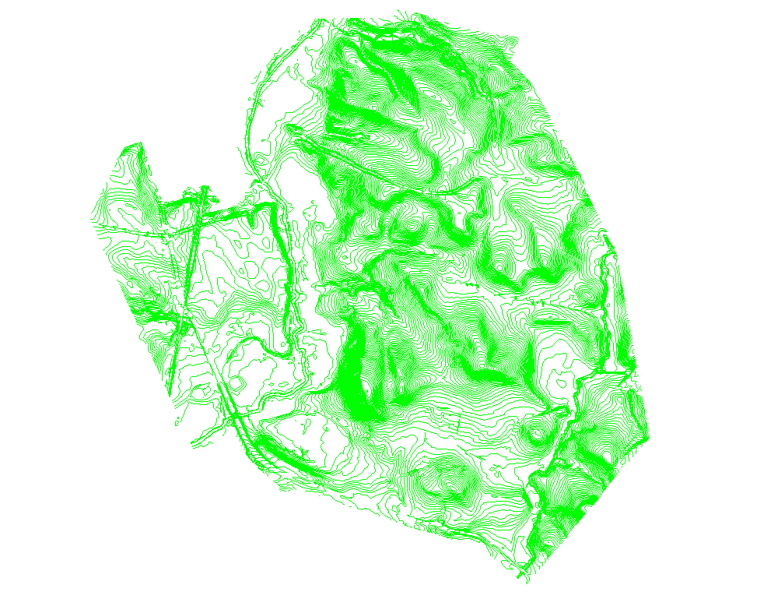
The model built from the contours has the following properties
Number of Triangles = 872062
Number of Vertices = 436760
Number of Breaklines = 436423
Max Elevation = 174.000
Min Elevation = 44.000
Surface Plan Area = 23331283.1 ft2
Surface Area = 23618002.2 ft2
The first thing to look at is the geographic size of the Original Ground Model versus the geographic size of the Finished Design model. If the Original Ground model extends beyond the Design or the provided borehole locations by more than a minimum amount, you are unnecessarily modeling data that is not required. This unnecessary data in many cases can be quite significant. Below shows the extents of the Original Ground Model and the Extents of the Finished Design Model.
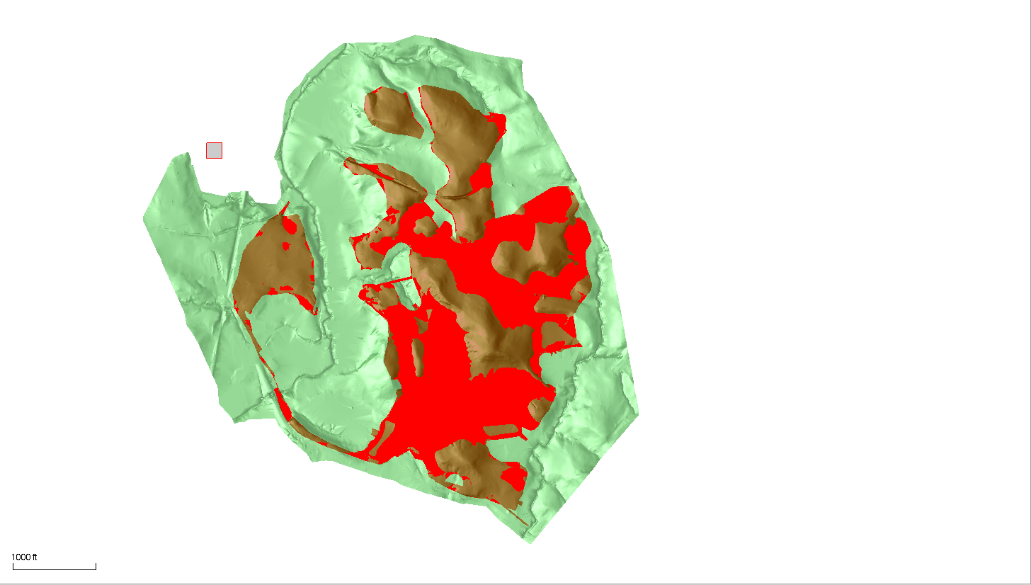
The Red color is where the Design is above Original Ground. The Brown color is where the Design is below Original Ground. The Green is the extents of the Original Ground. As you can see in this example the Original Ground area is significantly larger than the Design area. Looking at the Plan Areas of the two surfaces we have the following
Original Ground Plan Area = 23,331,283 ft2
Finished Design Plan Area = 9,601,290 ft2
The Original Ground model is 2.43x the size of the Finished Design model i.e. it can be reduced by >50% without making any changes at all to the source data.
When we take into account the location of all the Site Boreholes, we can derive an Original Ground Model that covers all Borehole locations and the extents of the Finished Design model. In the example below, this boundary is still larger than it needs to be, however it covers a plan area of 15,966,968 ft2 which is 68.4% of the original model size.
If we apply this boundary as a clipping boundary to the provided original ground contours, and then model the remaining portions of the contours, the resulting surface model has the statistics shown below.
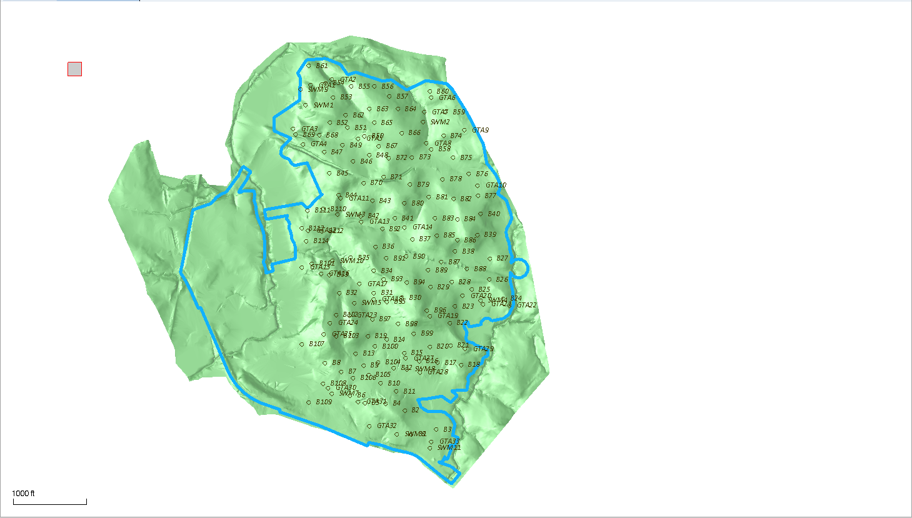
Reduced Surface Model Statistics
Number of Vertices = 287,512 (65% of the original number)
Number of Triangles = 571,754 (65.5% of the original number)
Max Elevation = 174.00
Min Elevation = 46.00
Plan Surface Area = 15,966,938.6 ft2 (68.4% of the original area)
Surface Area = 16,144,632.4 ft2 (68.4% of the original area)
This alone would have a significant impact on the speed of computations.
Filtering the Contours
As explained earlier in the document, the engineer creates a surface TIN from the surveyed points and lines for the Original Ground survey. The TIN is then contoured – typically people curve fit contours to make the contours look “nicer” on the plans. The curve fitted contours when written to a DWG or PDF file are often chorded or splined. Those curve fitted contours have already introduced errors into the measured Original Ground Surface (if you consider the measured points and line data model to be the “Real Truth” for the existing conditions. The example later in this document explores those errors in some degree of detail.
When imported into BC-HCE, those “Curve Fitted Contours” are now considered to be the “Contractors Truth” i.e. the best data that you have to work with. In the following section we will explore the effects of filtering the vertices of the contours using the Business Center – HCE Project Cleanup command. In each case we filtered the Original Contours using a different filter tolerance, created a surface from the resulting contours and then compared the filtered surface with the surface created from unfiltered contours to see the “volume errors” introduced through the filtering process. Below is a table of the results
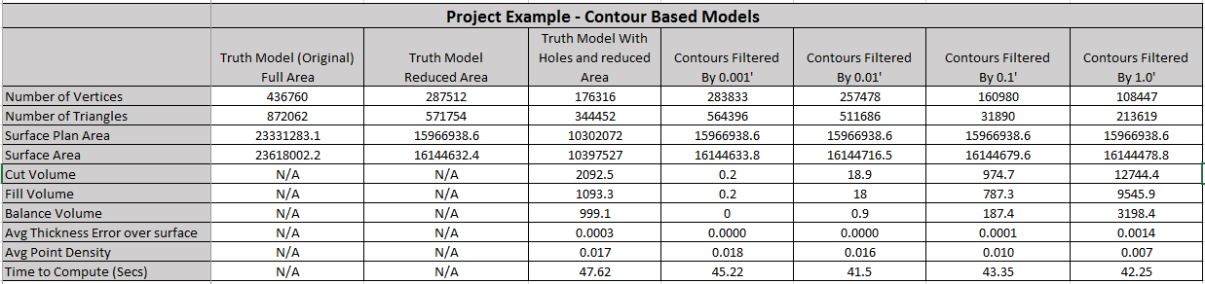
In all cases the time to compute the difference model was not significantly impacted because in all cases the larger model was the unfiltered contour model which has the largest number of vertices, and that was constant throughout the test. You can clearly see that as the larger filter is applied, the number of vertices is reduced (and therefore the number of triangles in the surface). In all cases the Plan area is constant, the surface area varies because it is made up of decreasing numbers of vertices. If you look at the volumes, you will see that the Balance Volume increases with decreasing vertices, as do the Plus and Minus volume errors, however when you distribute those errors over the entire surface area the average elevation error is at worst 1/1000 of a foot. This supports the reality that as you decrease the density of the source data, the introduced Plus and Minus errors cancel to a large extent. When you consider that the Cut and Fill volumes to the design for this project are in the realm of 1.6 million CY, the errors here are negligible. The errors here are also significantly less than the errors introduced by curve fitting the contours in the first place. The errors are also way lower as a % than the error introduced by getting Shrink and Swell factors wrong for the project.
So it is clear that with a radically reduced contour model, we can still achieve a 99%+ agreement on the volumes between surfaces based on the TIN Methods.
Note also in this case that the plan area of the Design Surface is only 9601290.1 ft2 compared to the Original Ground Model Surface area of 23621556.3 (this is only 40.6% of the Original Ground area). Applying a boundary to the original ground model that is closer to the design limits reduces the number of vertices in the original unfiltered contour based model 35%.
But what happens if we grid the Original Ground Model.
Grid Surface Models
In the following exercise, we took the Original Ground Model created from the unfiltered curve fitted contours. We used the Create Surface Elevation Grid to create CAD Point data at different grid intervals across the Original Ground surface. We then repeated the volume calculation between the Unfiltered Contour Model and the Gridded models. The results are tabulated below.
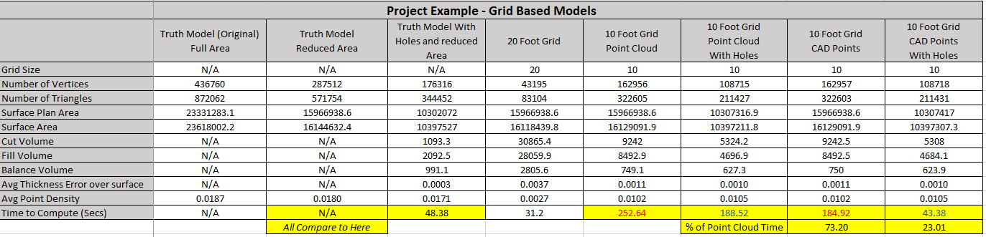
You can see a similar trend in this data to that encountered by filtering contour vertices. The biggest difference here is the significant reduction in surface vertices, when using e.g. a 10’ or 20’ Grid model across the surface. A 10’ Grid in this case was almost equivalent to the contour model filtered with the 1.0’ filter, however the “errors” introduced are lower than those from the 1.0’ filtered contours.
On paper we expected to find that modeling the points as CAD points vs Point Clouds would give us exactly the same results, while Point Clouds would give us improved graphics performance and some additional flexibility. While to a large extent this was true, we did find that in certain scenarios, the Point Cloud model computed volumes more slowly. This is an area where we can optimize further our computation engine to increase performance as shown by the time boxes in yellow.
This data again shows that Gridding the Original Ground model introduces some plus ad minus errors, but again that those errors to a large extent cancel out (as seen by the Balance Volumes). The process for sure also decreases the “Fidelity” of the Original Ground Model, so while it provides an adequate basis for Takeoff quantities, it should not be used to generate the final Cut Fill map for a project (which should use the full fidelity model).
Volumes to the Finished Grade Model
To complete this exercise we computed the Cut / Fill volumes for the project from each of the filtered or gridded surface models to the same Finished Design surface model, so that we could review the computation speed and variation in the volumes between methods. The results are shown below.
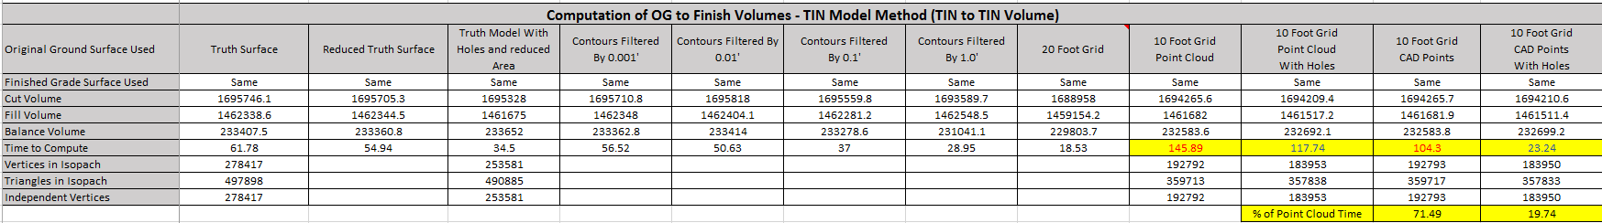
This table shows the following
- Filtering contours reduces processing time
- Gridding Original Ground at increasing grid intervals increases processing time
- A 1.0’ filtered contour set produces a balance Volume difference to the Truth data of 2366 cy in a total balance of 233000 CY and of a Cut quantity of 1,695,746 CY and Fill quantity of 1462338 CY. This equates to an error of 1%.
- A 20’ gridded original ground model produces a balance volume difference of 3603 CY which equates to an error of 1.5%
- A 10’ gridded original ground model produces a balance volume difference of ~800 CY which equates to an error of ~0.3% in the balance quantities.
- As will be seen below. Curve fitting the contours introduces errors greater than this into the model initially. In addition errors in Shrink and Swell factors will introduce larger errors than this into the overall quantity computations.
- In all cases, Filtering or Gridding the original data will dramatically reduce the computation times for Takeoff, especially when you have many strata layers and many boreholes, or when you start to apply large numbers of AOIs to the computation.
- Changing to a “full fidelity” Original Ground, but locking the Strata layers based on a lower fidelity Original Ground is a strategy that will pay dividends in the computation of surfaces and quantities on a complex Takeoff.
- While developing a Takeoff and running interim reports, work with lower fidelity Original Ground and Strata layers, and switch to higher fidelity when running your final reports will pay off in production gains throughout the process.
Below are the final Analysis Statistics for the above data if you are interested
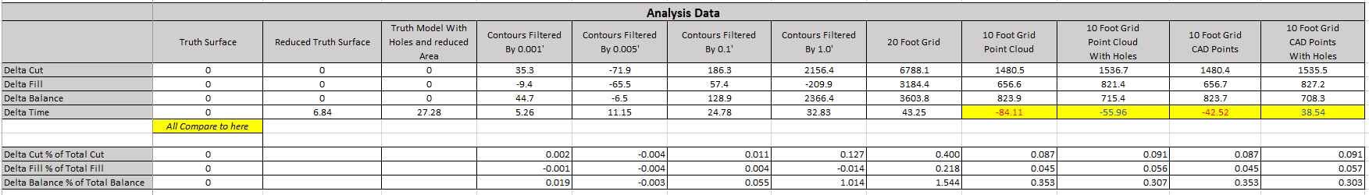

Example – Curve Fitted Contour Surface vs Original Surface
In this example we are going to look at the difference between a “Truth Surface Model” created from Survey Points and Lines vs a surface model created from the curve fitted contours created from the Survey Points and Line surface model. This will demonstrate the typical “Accuracy” that can be expected by modeling curve fitted contours as provided by the engineer or surveyor.
We start in a Business Center – HCE (BC-HCE) project and import the survey points and linework for an Original Ground Survey. The Points and Lines are shown below.
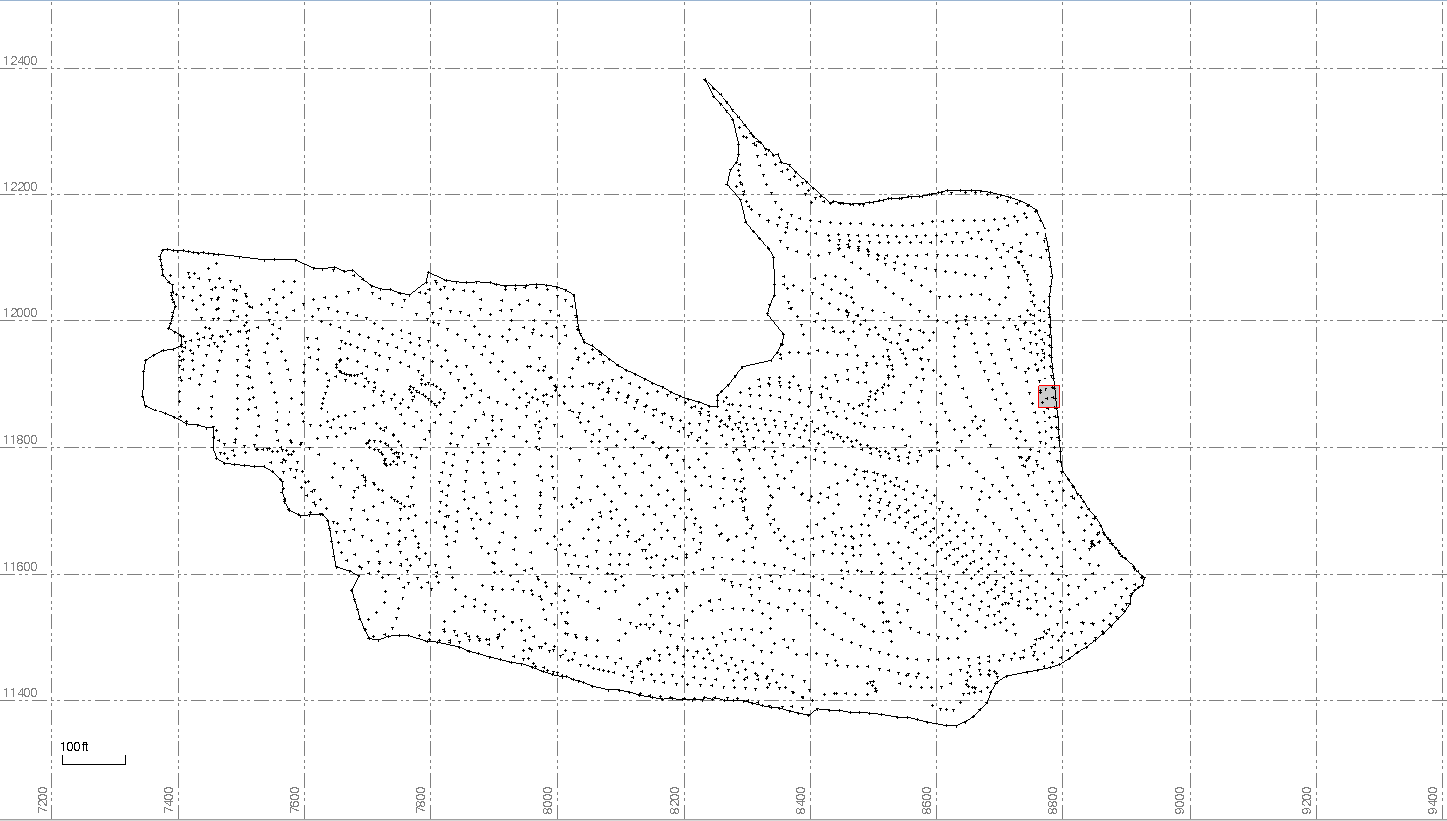
First we form a TIN model using BC-HCE of the surface and we will use this as the “Truth Surface” for the exercise that follows.
Below is the TIN Model that was formed.
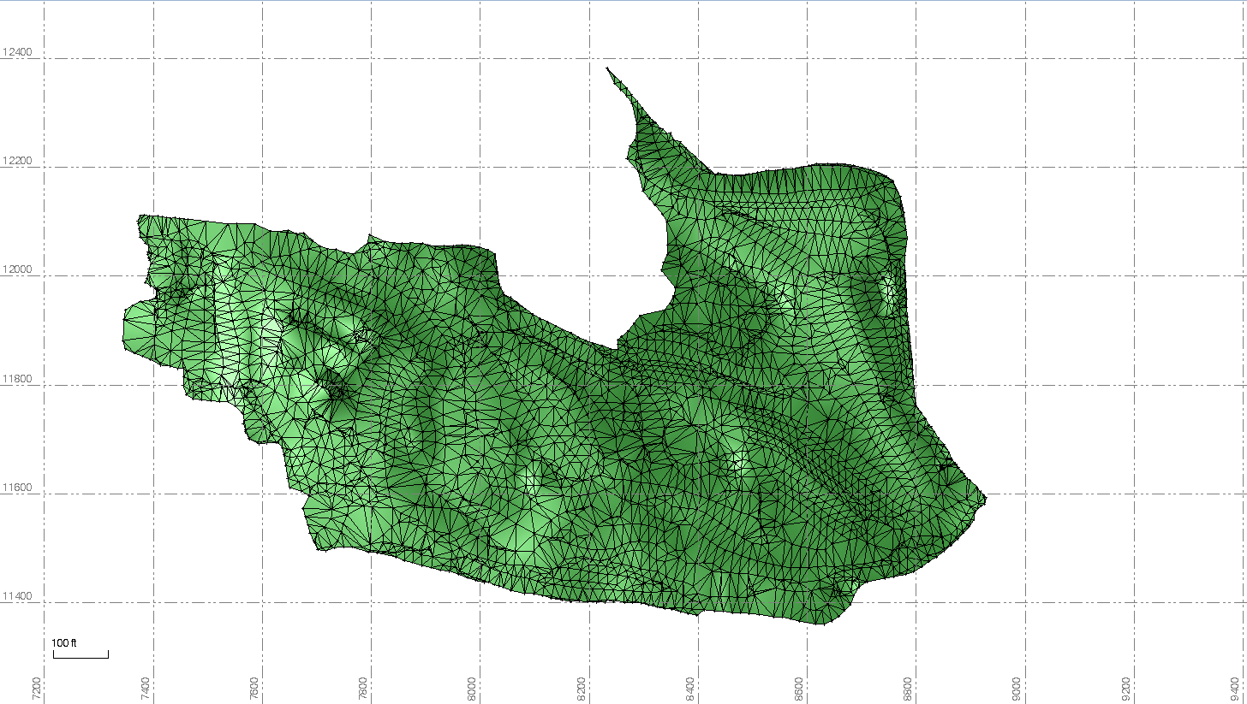
The TIN has the following statistics
Number of triangles = 5608
Number of vertices = 2974
Max elevation = 577.596
Min elevation = 383.198
Surface plan area = 858332.1 ft2
Surface area = 883377.9 ft2
The point density of this surface is 0.003 points per square foot or 0.346 points per 10’ square (110 square feet) or 1 point per 300 square feet (17x17 foot square).
We will use this surface to now create curve fitted contours at 1’ intervals. Below is the result of that process.
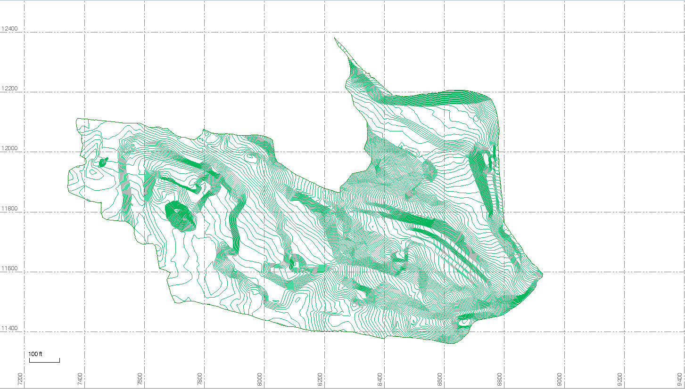
Now we will use the same boundary as was used in the Truth Surface Model and create a second model using the contours and edge breakline. Below is the surface model result of this process.
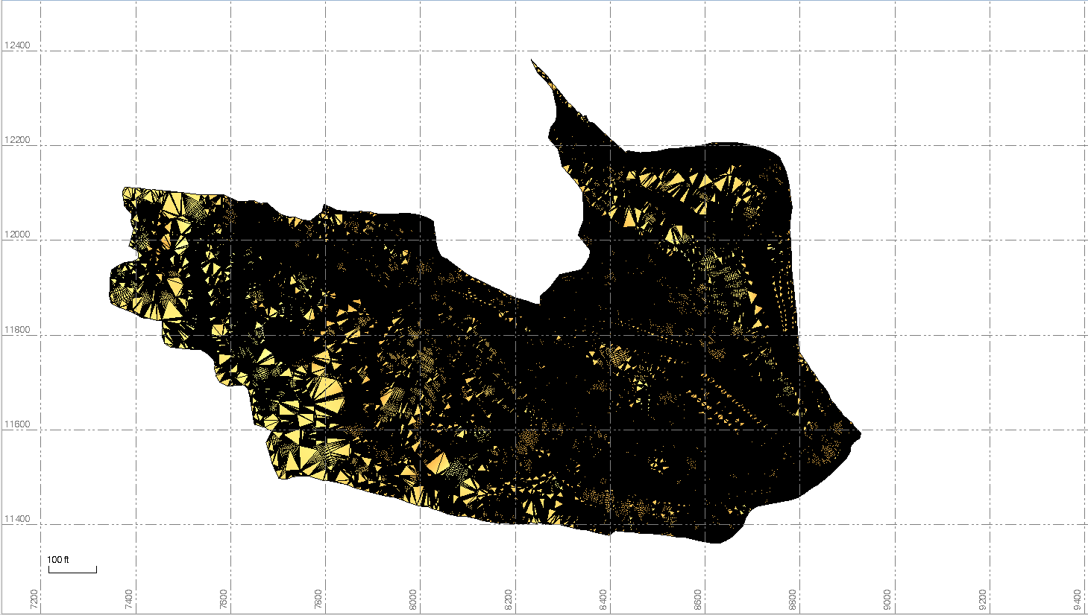
You can instantly see that this second surface has many more triangle faces than the original surface model. Let’s take a look at the statistics for this surface
Number of triangles = 339952 (this is 60x more data than the original)
Number of vertices = 170374 (this is 57x more than the original)
Max elevation = 577.000 (Because we used 1’ contours this is .596’ lower than the original)
Min elevation = 383.198 (This is the same as the original)
Surface plan area = 858332.1 ft2 (This is the same as the original)
Surface area = 881837.0 ft2 (This is 99.8% of the original)
The point density of this surface is 0.198 points per square foot or 20 points per 10 foot square (100 square feet).
If we compare the two surfaces in the plan view, we can see that the Curved Contour based surface (Orange) randomly is higher and lower than the “Truth Surface”
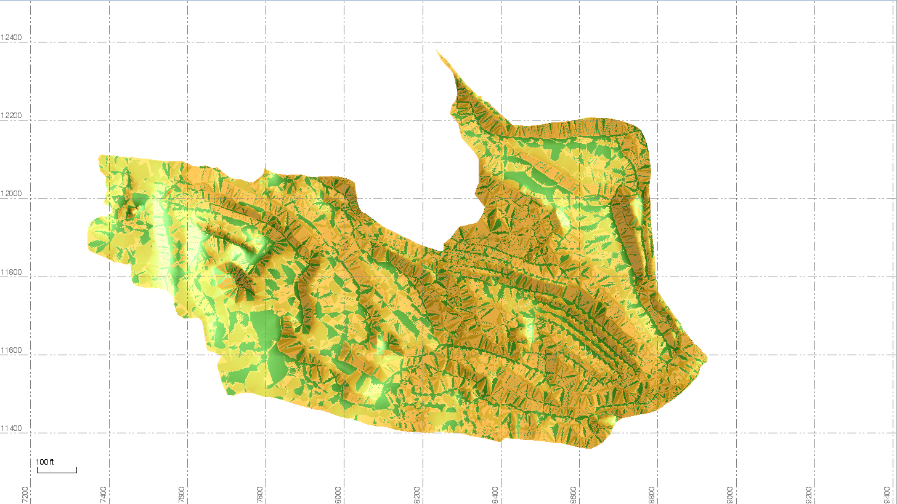
If we generate a Volume between the Truth Surface and the Curved Contour Surface, the result is shown below
Cut Volume = 983.6 yd3
Fill Volume = 994.7 yd3
Balance = 11.0 yd3
Note that this surface covers a significantly smaller area than the first example – the surface areas in the first case study were 27x larger than in this example (so to compare here that would equate to a Cut Volume error of 26600 CY and Fill Volume error of about the same magnitude).
As expected, there is a +/- difference between the two surfaces, however the + values balance the – values and the net result is all but zero. The sum of the two errors = 1978 yd3 and if you distribute that evenly over the entire surface area of the surface model this would equate to a thickness of 0.0022’ which is well below the tolerance of the measurement process that did the original survey, and for sure below the tolerance of estimating.
As a second exercise, we also gridded this surface as a second example at 5’, 10, 20’, 25’ and 50’ intervals, created surface models of each grid and then compared the volume differences and surface model statistics between the Truth Model and the gridded models. The results are shown in the table below.
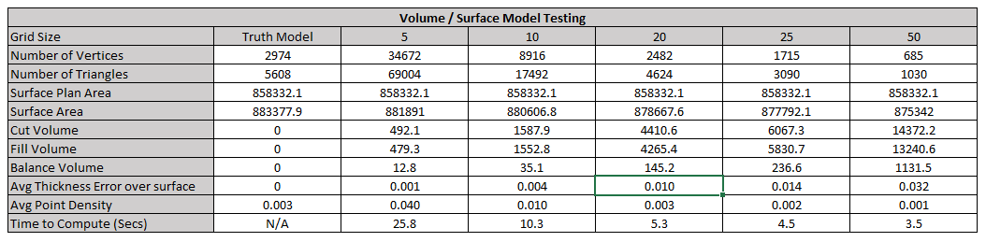
This table doesn’t draw any real surprises, it simply confirms the following
- The best surface model is made from the original point and line data. This provides the best mix of minimum number of vertices and surface model “accuracy” and also downstream computation speed for the surface model rebuild and also the computation of surface to surface volumes
- As you decrease the grid spacing, the surface model create approaches the Truth Model in terms of accuracy, however at 20’ the error introduced is less than 1/100th of a foot over the entire surface in question
- The computation time for a surface to surface computation increases exponentially with increasing number of points / vertices in the model
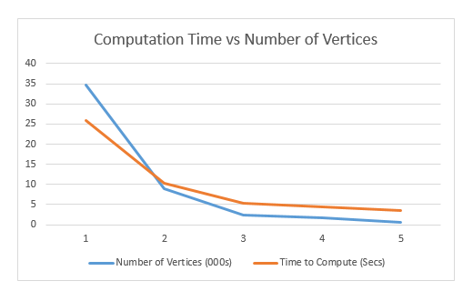
- The Volume Balance error is inversely proportionate to the number of vertices, i.e. As the number of vertices increases, the volume “error” decreases

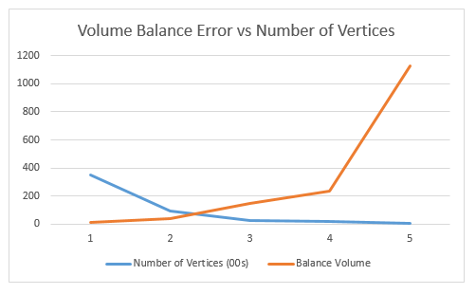

- The volume error is typically balanced either side of zero giving an approximately equal positive and negative error, thereby creating a Net Zero effect on the total volume computations. In all cases the error when distributed over the entire surface area is negligible in comparison to other sources of error on the estimation of volumes including
  - The effect of Shrink, Swell and Bulking factors
  - The errors associated with computing strata from a limited number of boreholes
  - The errors associated with computing the Original Ground surface model from provided curve fitted contours
  - The errors associated with digitizing
  - The errors associated with measuring the Original Ground depending on the methodology used
    - Rod mounted prism or GNSS receiver – Walking the site
    - ATV / Truck mounted prism or GNSS receiver – Driving the site
    - Drone measured surface interpreted from aerial photos
    - Commonly available sources of DTM information
    - GNSS vs Optical measured surface accuracy
    - Measurement using a Topo Shoe vs Rod with point
- Surface Area of the model even at 50’ grid interval is still 99% of the Truth surface model
- The Average Point Density of the original survey is equivalent to a 20’ Grid surface model
What is clear from these exercises is that you can significantly dilute the Original Ground Surface Model and the associated strata surface models without significantly impacting the estimated / computed earthworks quantities. This statement is likely more true for Green Field projects than for urban redevelopment projects, but most of the conclusions still apply.
Based on these tests, with this data you can clearly see that a 20’ Grid model for the Original Ground and associated strata layers in a Takeoff will provide a significantly smaller dataset for the computations than using a surface model computed from the curve fitted contours, without compromising the volume computations by >1%. In terms of computation time, you can see the impact of going from <3000 vertices to >170,000 vertices and that will be compounded when you duplicate that on multiple strata layers.
Note:
If you grid the Original Ground model at a smaller interval e.g. 10’, and then convert it into a Point Cloud, you then get all of the benefits outlined earlier in this document relating to creating models from Point Clouds. The most valuable being the ability to subset the point cloud to reduce
- The area of coverage so it is slightly larger than the finished design surface
- The selection of a subset of the point cloud to form the surface models either for Original Ground or the associated strata layers.
You can see the effect of the Gridding when you take a profile comparing the “Truth Model” to e.g. the 20’ Grid model – below is an exaggerated vertical profile and an unexaggerated vertical profile. The green profile is the “Truth Surface”.
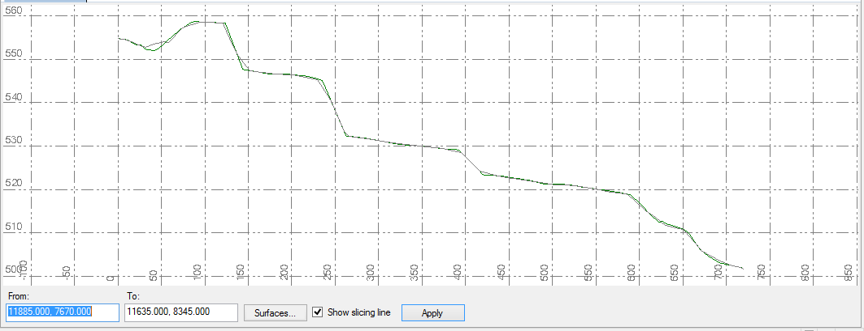
Exaggerated Profile
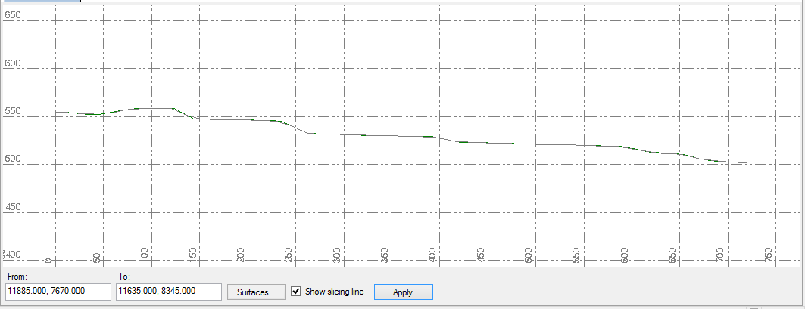
Unexaggerated Profile

Hopefully this report is useful, and will help you to identify better ways to optimize your Takeoff processes.
The key takeaways are
- Reduce your Original Ground surface model area so that it closely matches your Design surface area
- Filter contours to remove vertices before you build your existing ground model. Using a filter of 0.1’ is safe and 1.0’ is reasonable as a tolerance in most cases.
- Try gridding your Original Ground surface to create points at a 20’ interval for the purposes of modeling strata layers. Model the strata and then lock them. You can then change your Original Ground model to increase its fidelity to e.g. 10’ grid or full original source data (filtered or not)
- Make sure that your boreholes are added to your Original Ground surface model
- Model CAD Points as Point Clouds to improve graphics / election speed on projects
- Use the data optimization tips to improve your data for optimized performance on projects
- Minimize the Strata layers to just what is important for the construction process or needs of the estimate. Creating a strata layer for every surface listed in every borehole is likely overkill for most projects. The key surfaces are
  - Original Ground
  - Topsoil stripping
  - Contaminated materials
  - Rock
  - Materials that need special handling or treatment
  - Materials that drive over-excavation constraints
  - Materials that cannot be used for fill
- In most cases strata like Clay Sand, Silty Clay, Silty Sand, etc. can all be treated in the same way unless the geological report specifically states otherwise.
- Focus on creating good boundaries for your surfaces to minimize computation times

