Technical Reference Document

Validating a Pavement Surface Model for IRI Prior to Project Execution

Overview
A paving customer, building models for the machine using the Business Center – HCE corridor modeling tools wants to test the corridor model that they build at lane center (between the vehicle wheels) for potential IRI failures prior to project execution. This document reviews how to build the model and validate the model using the IRI reporting capability.

Technical Detail
To test the model at lane center using the IRI report, the model will need a breakline that runs down the line(s) that you want to test the model along. To achieve this, if the lane width is e.g., 12’ at -2% slope, then you will need to build a corridor model with the following instructions
Right Side Instructions
From HAL (Alignment) to LC1R (Lane Center 1 Right) – Offset = 6’, Slope = -2%
From LC1R to LE1R (Lane Edge 1 Right) – Offset = 6’. Slope = -2%
Left Side Instructions
From HAL (Alignment) to LC1L (Lane Center 1 Left) – Offset = -6’, Slope = -2%
From LC1L to LE1L (Lane Edge 1 Left) – Offset = -6’. Slope = -2%
Once you have the corridor model, we recommend that you densify the Corridor Surface Model. To do that, select the corridor surface model from the plan view, Right Click and select Properties. From the Properties pane, at the bottom select Densify = Yes and set the tolerance to be e.g., 0.005 or 0.01 etc. The surface model will densify to make it more accurate.
Note: The greater the surface model densification, the lower the IRI should be for the corridor when tested. Having said that there are a few factors that you should consider here
- The further the line is from the centerline of the road will typically increase the IRI because changes in cross slope have a greater change in elevation the further you get from the centerline.
- When you come to the start or end of a superelevation transition, what was a constant cross slope now becomes a changing cross slope – inevitably this creates a break in the longitudinal profile of the created line. These breaks in slope will affect IRI at those break points and they will also likely be flagged as scallop points (up or down). If you add vertical curves into the superelevation, that will smooth the transition in and out of super which will create a smoother transition at these locations for the purposes of IRI.
You may also want to set your Maximum Sampling Distance for the corridor model to e.g., 12.5’ as well as the densification properties. To do this select Project Settings, and then Computations, Corridor and then Maximum Sampling Distance = 12.5’. You can also change it in the corridor template properties – Use sampling distance (change tis to This template) and then set the maximum sampling distance to 12.50.
Now that you have a densified corridor surface model, you will need to extract the breaklines for the corridor, to create the breaklines that run down the centerlines of the Left and Right lanes. To do this, from the Edit menu select Explode. Select the Corridor Surface Model and the linework will be created on a layer with the same name as the source corridor model.
To use the 3D breaklines in the analysis for IRI, you will need to convert the 3D polylines into 3D alignments. To do this use the Create Alignment command and utilize the “Use existing line” option to add each 3D polyline to a different alignment.
You can also create a line that is at the center of lane in 2D and then use the Change Elevation command to drape it on the corridor surface model and then use the now 3D line in the IRI calculations.
Running the IRI Computations
There are three types of IRI analysis reports as follows
- Fixed Distance – this analyzes IRI over a user defined segment – the classic IRI reporting is carried out on 0.1 mile (528’) segments. Each segment is reported with its own IRI calculation. Scallops (grade breaks where the mid segment to mid segment line that passes over a break point in the line under analysis has a delta elevation greater than the report setting for scallop height at the break point.

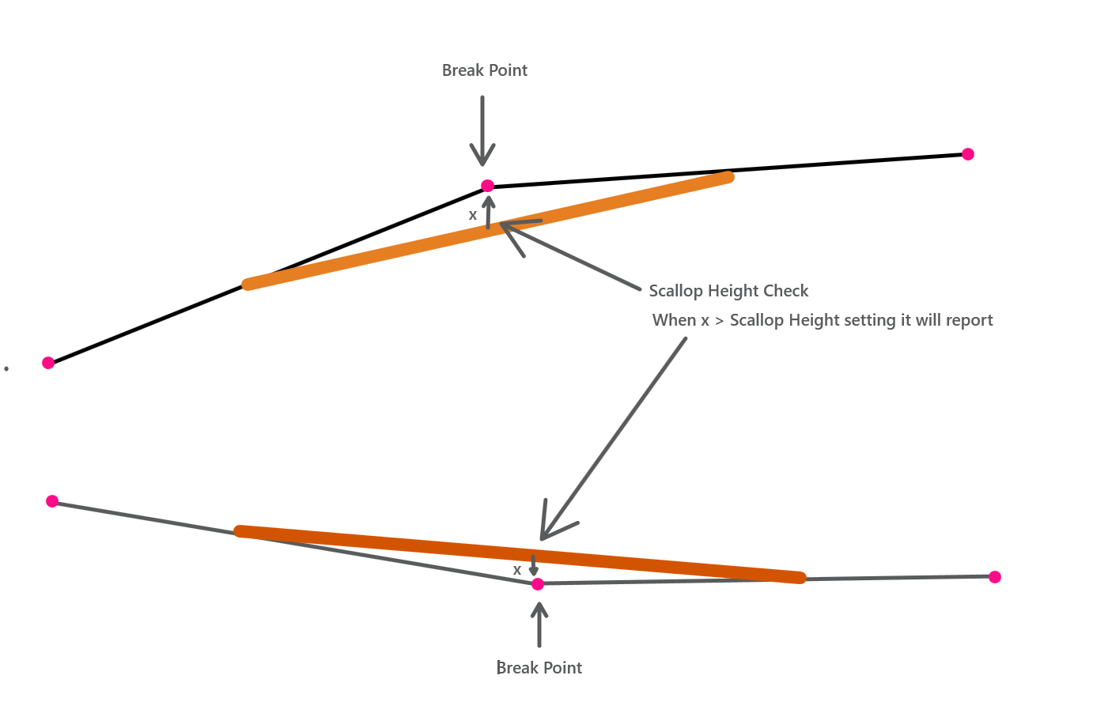

- Continuous – this analyzes the IRI over the entire length of the line on a continuous sliding basis and reports at every sample location
- Overall – this analyzes the overall IRI profile for the selected lines and delivers a single set of results for each of the lines selected.
These three reports are equivalent to the ProVal Fixed Interval, Overall and Continuous Ride Quality reports.
Note that the reports will generate a report for each line individually as well as an average for all of the lines selected at each station location or segment range. You should only analyze lines that go together to make a single planar road surface element – i.e. do not incorporate lines that would be on different slopes in the same cross section.
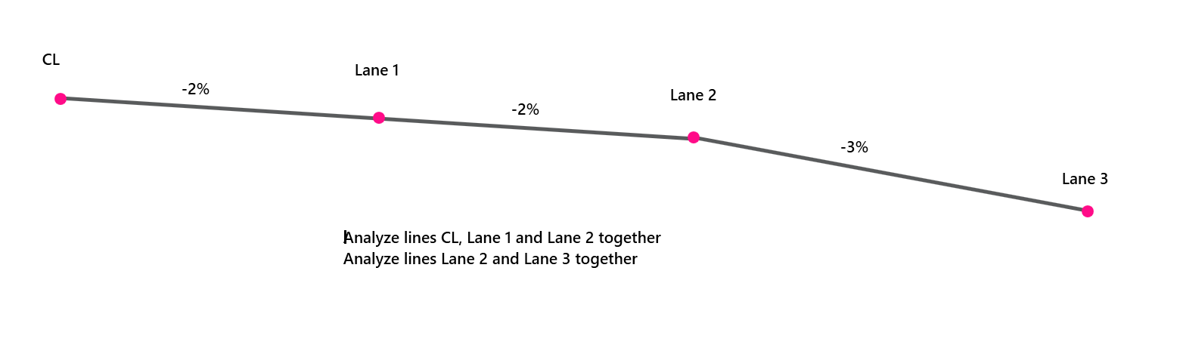
The IRI Roughness index Report command dialog looks as follows
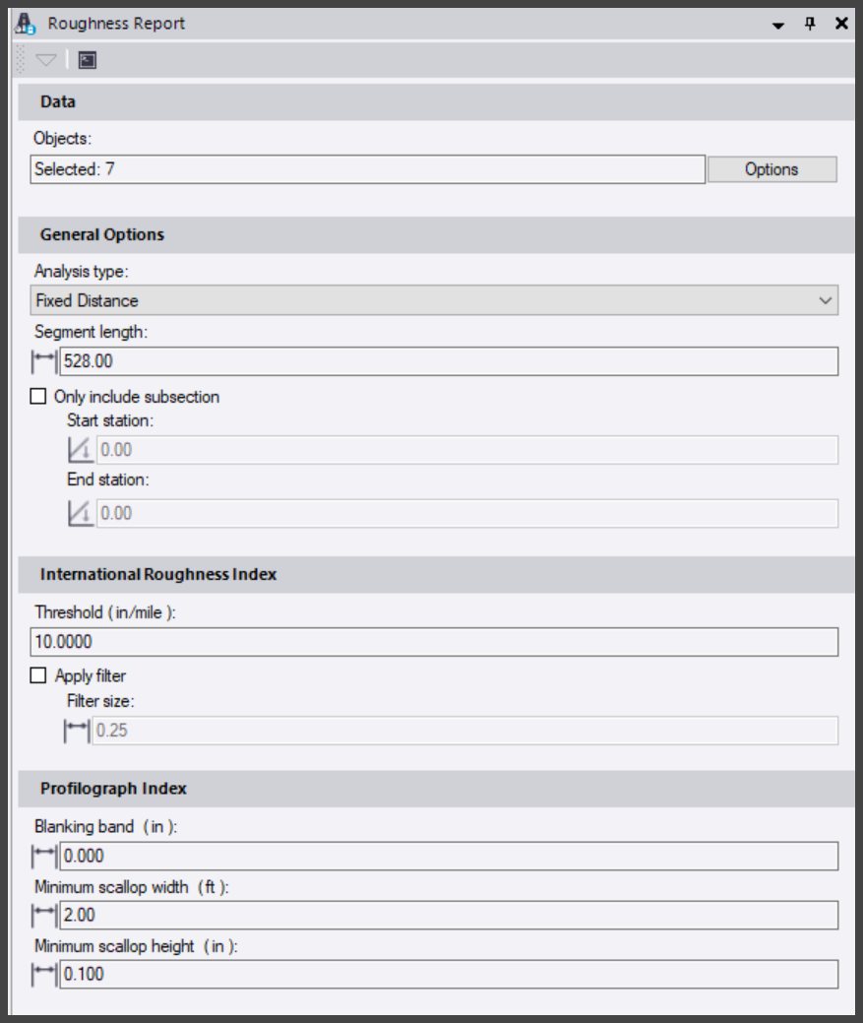
Fixed Distance Settings

- From the Corridor Menu, select the Roughness Index report
- Select the alignments that you wish to analyze for IRI
- Enter the settings required for the IRI reporting as shown above for the Fixed Distance analysis.

- Select the Analysis Type = Fixed Distance
- Enter your desired segment length – US DOT standard is 528’ (0.1 mile) for Fixed Distance Analysis
- Specify a subsection of the road if required by defining a Start and End station
- In the International Roughness Index area of the dialog
  - Enter your IRI High Value threshold e.g., 20 inches / mile. This is the value that below which you are targeting for the results being generated.
  - Apply filter and Filter size are not necessary for model based calculations, this is designed for paving operation analysis where you may get the odd short length data spikes caused by debris on the surface being profiled.
  - For the Profilograph index
    - Enter the Blanking band at 0.20”
    - Minimum scallop width at 2.00’
    - Minimum scallop height at 0.1”
- Run the report.
- You will find that by selecting the Left or right or both lanes will generate slightly different reports. You can change the densification tolerance of the corridor and explode out new linework adjust the computation intervals to see the effect on the IRI reports.
- A technical reference document has also been provided as background reading.
- A copy of the BC-HCE help system pages have also been provided as background reading.
Notes:
You can vary the densification properties of the corridor surface model to see the effects of densification or corridor sampling interval on the resulting 3D linear features with respect to IRI.
How Many Lines Should I Analyze at One Time?
You should only analyze lines that collectively act as a surface plane of the pavement surface. If the road surface is made up of 2 or more planes (lanes with different cross slopes) then they should be analyzed separately i.e. a 2 lane road will typically be modeled with a single plane on left and right side of the alignment whereas a 3 lane road will typically have a change in slope between lane 2 and 3 etc. In the 3 lane road then you should only analyze the lanes that have the common slope in one IRI analysis.
What Data Should I Select for The Analysis?
The analysis should be used with TBC Alignment objects or linear features generated from .PAV files generated by Trimble paving machine control systems. Currently the command does not stop you from selecting polylines, 3D polylines, linestrings, surfaces or corridor surface models. The process requires linear features that have a profile component – the paving lines and alignments meet those requirements. You can select any number of paving lines or alignments to execute the process. The system will compute average IRI as well as IRI values for each of the lines individually.

What Should You Expect to See in The Results?
A good IRI for a finished asphalt pavement surface will be in the range of 25 to 40 inches / mile whereas a concrete pavement will be more like 60 to 70 inches / mile. When IRI numbers get larger the road roughness, or the model roughness is increasing.
When you look at the results for a pavement surface model, you are of course looking for results better than those expected for a finished pavement surface, if the model cannot generate better numbers than those considered good to acceptable, then there is zero chance that the paver will improve the IRI values on the finished pavement. Model results should be in the 10 – 25 range for a fixed distance analysis result.
In the real world of concrete paving, there are many factors that will degrade the model accuracy to what will become the real world IRI on the finished job. The biggest factors will include the insertion of joint rods into the concrete or slump of the concrete around the rebar or joint rods. The concrete mix and material size will also affect the IRI results on the finished concrete along with the dynamic nature of the concrete screed. An asphalt paver has a floating screed that takes longer to adjust itself to a grade change, so naturally an asphalt paver will lay a smoother surface than a concrete paver.
When you look at the IRI values on a finished model, they will vary along the length of the alignment. What you should expect to see is IRI increases where “things are happening” in the model. By things happening we are referring to the following
- Horizontal Curves
- Vertical Curves
- Superelevation or cross slope changes
- Widenings
In horizontal and vertical curves and through superelevation, the model is densifying to compute the pavement surface to the accuracy you want to achieve to meet your tolerances (high low pavement tolerances). Because the model is densifying there are more triangles in the surface closer to each other which if anything is going to cause IRI increases, more triangles with changing slopes and elevations are going to be the cause. Where you have long straight grade sections i.e., no vertical curves, no superelevation and no horizontal curves, the triangles of the surface can get larger and that will reduce IRI noise and improve the IRI values significantly.
So, when you look at the IRI numbers in the report or you look at the charts of IRI vs station, you can expect to see the IRI values to increase where you have Vertical Curves, Horizontal Curves and superelevation occurring. The more that is going on in the model, the denser the triangulation of the surface will be and the IRI values will spike in those areas.
Also note that the tighter the vertical curve, the horizontal curve or the greater the rate of change of superelevation the higher the IRI numbers will get because the surface models will need tighter triangulation to be able to accurately model the surface changes that are occurring.
To get the best model IRIs for pavement surfaces, you should build the pavement models using horizontal and vertical alignments and either superelevation or slope table instructions. The corridor surface should be built from corridor instructions rather than from engineer provided 3D strings, that way TBC can compute the surface to the accuracy you want to achieve and densify the model where it needs to be densified to deliver the best possible surface. While you can use an engineer provided surface model and 3D strings, you should always check the model with the IRI analysis prior to field deployment and check that the model has all key locations in the surface i.e., where supers start and end or where widenings start and end and at start and end and high / low points of curves and at start and end of all horizontal geometry elements.
Tips For Modelers
Experienced users of Trimble Machine Control systems use a corridor modeling interval of 12.5’ for concrete paving and use a densification setting of 0.01’ tolerance. They will also extend the paving model out 5’ from the left and right side of a 2 lane pavement to increase the width of the pavement model and to thereby increase the size of the triangles at the edges of the pavement which improves IRI performance of the model and on the machine.
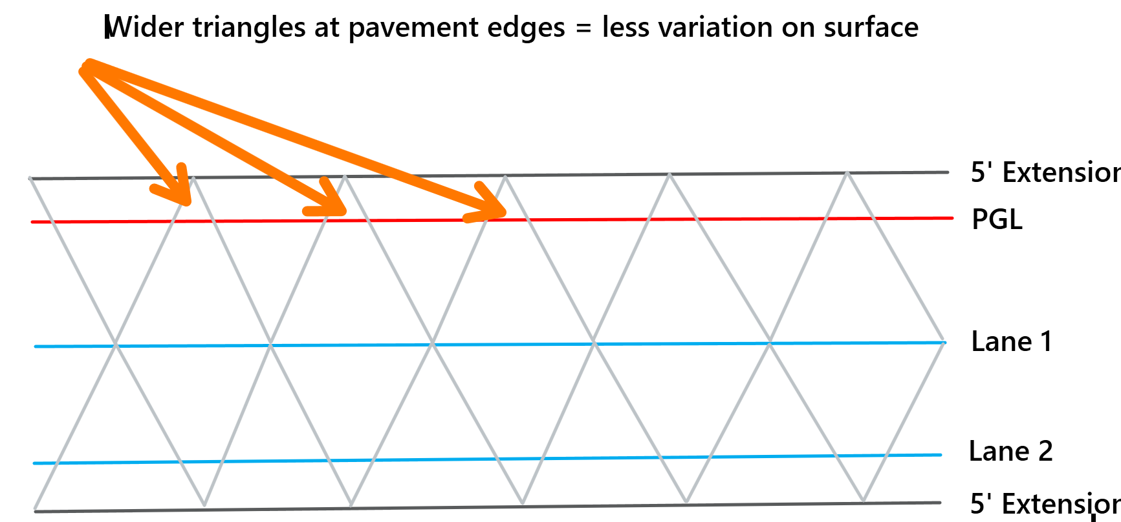

For ramps, you may want to apply vertical curves in your slope tables and superelevation models to smooth the transitions in and out of superelevation as that will have a positive effect on your IRI results for the pavement. Many contractors tell us that even when the design does not use vertical curves in the slope tables, they apply them anyway to guarantee that the IRI results will pass for the ramps in a project. Before doing this, you should discuss and get the approval for doing so from the project engineer.
Please contact me for more information if you have any further questions
Alan.Sharp@RockpileSolutions.com
+1 720 323 0481

