Technical Reference Document

Road Modeling Tips

This Technical Reference Document explores some of the lesser known capabilities of the Corridor Model functionality of Business Center – HCE. Hopefully the document exposes functionality that you were not aware of and that will be useful to you in the modeling process.

Clarifying Corridor Model and Corridor Surface Model
- When you create a corridor model in Business Center – HCE (BC-HCE) using the template method, the software automatically creates a Corridor Surface Model in the plan and 3D view graphics that represents the Corridor Model in 2D / 3D. It is important to understand that the Corridor Surface model is just a representation of the Corridor Model.

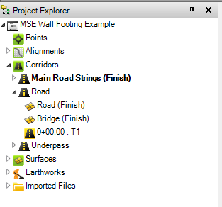
Corridor Surface Models in the Project Explorer
Corridor Model Template in the Project Explorer
Corridor Models in the Project Explorer

- The Corridor Surface Model comprises “Section Drops” calculated at specific stations along the corridor model. The corridor surface model is 100% accurate at those drop locations. In between the drop locations, the corridor surface model is less accurate than the Corridor Model from which it is derived, because it is computed by linear chording between the section drops. The corridor model is 100% accurate at whatever station it is queried. The “Section Drops” for the Corridor Surface Model are created at the following locations
  - Start and End of the alignment
  - At all of the PC and PT locations along the horizontal alignment
  - At all the VPI locations along the vertical alignment
  - At all locations where superelevations start and finish
  - At all locations where templates are placed
  - At all locations where offset values change based on 2D lines stored within instruction tables or where instruction tables vary the offset of lines
  - At station intervals as defined within the Project Settings – Computations – Corridor – Maximum sampling distance for the project e.g. every 25’ along the corridor. You can change this setting at any time to increase the accuracy of the Corridor Surface Model displayed.
- When you compute Corridor Earthwork reports, the Corridor Model is used to compute all of the quantities. The computations are computed at a defined station interval and at defined critical locations along the corridor by End Section Area methods.
- All Corridor Surface Models are by default “Alignment Based”.
- Corridor Surface Models can be “Densified” by changing the Densify Surface property to Yes and defining the tolerance required for the model. The tolerance is an Arc to Chord offset value that once exceeded causes an additional Section Drop to be placed. This has the effect of adding more section drops through horizontal and vertical curves and through widenings and superelevation areas of the corridor. The lower the value entered for the tolerance, the greater the densification that is applied and the more accurate the model becomes. Note that applying densification will result in longer update times for corridor models (large projects) in line with changes that you apply. Densify surfaces only when you are ready to use the surface models in the field or when you need the increased accuracy in the office to maintain optimal production.
- The Corridor Surface Model can be deleted, and it will have no effect on the Corridor Model itself, other than you will not have a Plan and 3D representation of the Corridor Model.
- The Corridor Surface Model has a property that can be changed that allows the Corridor Surface Model to show any surface (Material Layer) of the Corridor Model. I.e. if you create a Material Layer called “Over-Excavation” and assign some instructions of the Corridor Model to that Material Layer, you can change the property of the Corridor Surface Model so that it shows the Over-Excavation surface in the Plan and 3D views. Below is the same E-W Road, now displayed using the Over-Excavation Material Layer (Lowest Points in the displayed Cross Section view.
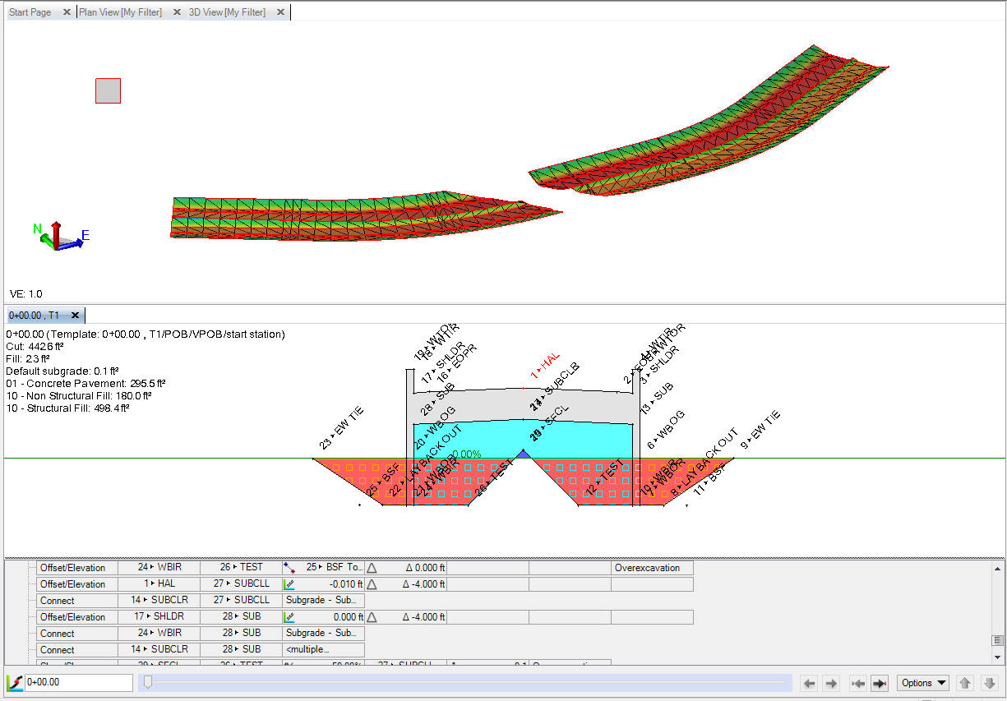
- The Corridor Surface Model when it is created, is always given the default naming, i.e. it is named the same as the Corridor and is suffixed with (Finish). This can be confusing if as in (7) above you later change the property of the Corridor Surface Model to Over-Excavation and the Corridor Surface Model still shows Corridor Name (Finish). You can change the Name property of a Corridor Surface Model to represent what you are trying to show using the model.
- You can create as many Corridor Surface Models from a single corridor model as you need. Each Corridor Surface Model will reference the corridor model. Each Corridor Surface Model can reference a different “Material Layer” surface from the reference corridor model. Below you can see the MSE Walls Material Layer from the E-W Road Corridor Model.

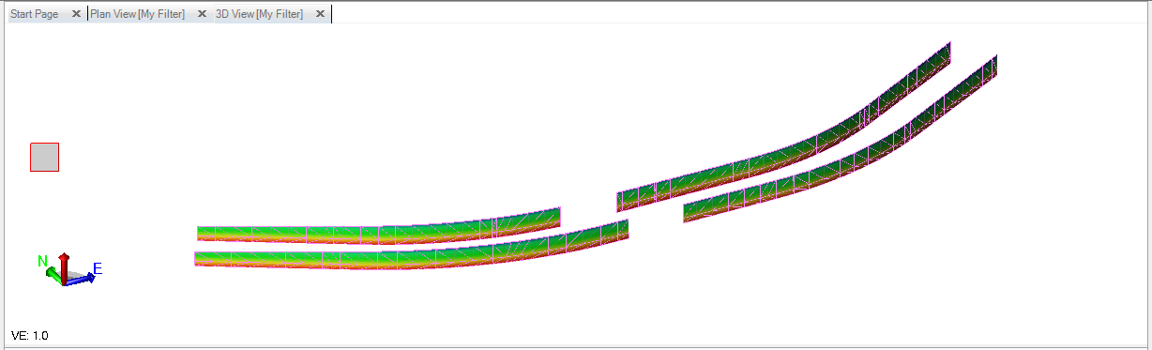

- When you have a normal TIN Surface model, and you add it to a Corridor Model using the Surface Template instruction, the Corridor modeling process incorporates the added surface to the Material Layer that you define. Once added the Corridor Model is using the surface as provided and will provide Cut and Fill information to the Original Ground surface referenced to the corridor. The corridor model is using the provided surface exactly as provided.
  - You can add a Material type that sits above the surface if the surface you added is not the Finished Design surface i.e. a Subgrade Surface.
  - You can add surface instructions to the Left and Right end of the surface template instruction that was created e.g. in order to tie the surface instruction to the Original Ground surface model referenced to the corridor model.
  - You can also add template instructions for template data that sits below the surface instruction e.g. to add subgrade to the Finished Design surface created by the surface instruction.
Note: When a corridor model is created, prior to any instruction being added to the Template, a placeholder Corridor Surface Model is created automatically.
Note: When a surface instruction is created, BC-HCE does not know what else you will be doing to the template being created, so it automatically writes Corridor Surface Model information to the placeholder Corridor Surface Model. If you were creating any of the normal template instructions, this makes absolute sense because the Corridor Surface Model is being created for visualization purposes, and providing a result surface that you can share with field systems. However in isolation, a surface template instruction is converted into a corridor surface model (which makes less sense because you started with a perfectly good surface, however you may want to extend the surface laterally or vertically, in which case the Corridor Surface Model representation makes more sense). The surface template instruction is converted into a Corridor Surface Model by slicing the provided TIN model at the critical locations of the road alignments (PC, PT, VPI etc.) and at the intervals defined in the Project Settings (e.g. every 25’).
If the Corridor Surface Model that is created (written back from the Surface Instruction) is not needed i.e. you don’t intend to extend the surface instruction laterally or vertically, and you don’t need to visualize it (because you already have the source surface of the surface instruction), then you can delete the written back Corridor Surface Model as it is surplus to requirements. The Corridor Model is left intact and you can use it for running corridor earthworks reports as normal (between Original Ground and Design surface for example).
If the Corridor Surface Model is required for some reason, and you see that it looks incomplete i.e. it has bands of the corridor from Left to Right that are missing, this is caused by the surface model being sliced and in some places a slice only has one part, whereas in other sections it has two parts – i.e. there are two partial section drops with a slight or large gap between the parts (below is a diagram of how this happens). The only cure for this is to modify the original TIN surface so that when sliced it doesn’t have two parts. As has been stated before, the corridor model and the corridor earthwork reports will be correct, it is only the graphical presentation of the corridor surface model created from the corridor surface instruction that is incorrect. The following actions can mitigate / minimize the impact (but not eliminate the issue entirely). Fixing the source corridor model is the only way to fix the problem entirely.
- You can change the Project Setting for Maximum Sampling Distance to a smaller interval. By decreasing the interval the computed drop sections are closer together, and therefore the separation between a drop section made of one part and a drop section made of two parts is minimized, thereby making the gaps in the model smaller.
- Changing the Surface edge angle in Project Settings – Computations – Corridor can also improve the look of a Corridor Surface Model where the edges of the original TIN model have many jog in / out at sharp angles. Typically we set the setting to a value of 22.5 degrees, but you can reduce it further to e.g. 15 degrees and see what that does to the result. Note that the smaller the angle value in this setting, the more section drops that are created to get closer to the original TIN model. Again, the Corridor Model is correct everywhere, it is only the derived Corridor Surface Model that has these issues.
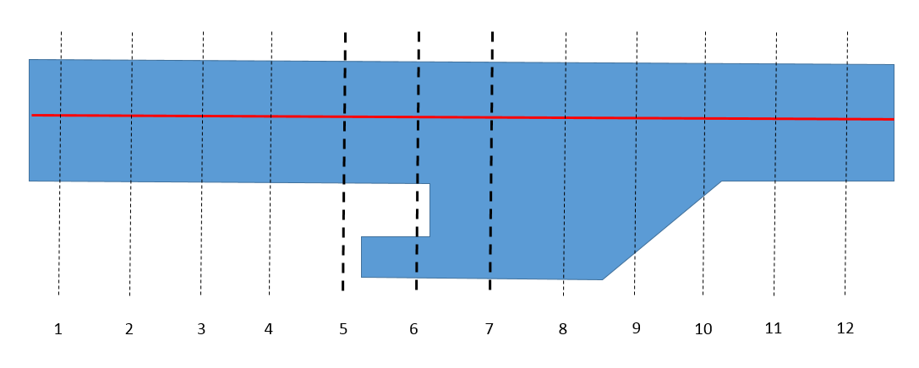
Blue = TIN Surface Model. Dashed Lines = Section Drops.
At Section 1-5 and 7 -12 the Section Drops are one part sections
At Section 6 the Section Drops is in two parts
The Resultant Corridor Surface Model would look as follows because from section 5-6 and 6-7 there is ambiguity in how to link the sections, so the links are left empty between 5 and 7.
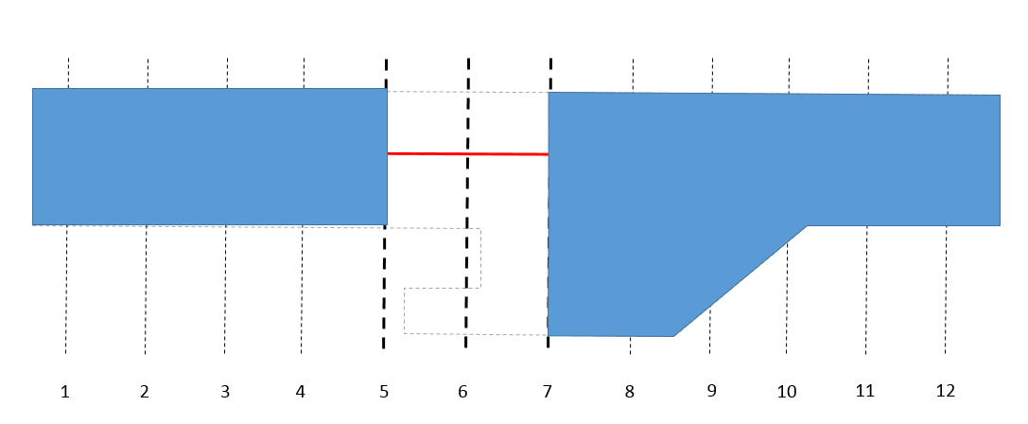
If the gap created to the South side of the corridor (by the original TIN) can be closed by drawing in the Green Breakline shown above and adding it to the TIN Surface Model driving the Corridor model, then the problem shown here can be resolved because the “Gap” would be closed creating a single Drop Section Part at all 12 section locations.

Using Boundaries with Corridor Models and Corridor Surf ace Models
- You cannot apply a boundary to a Corridor Model in order to preclude the model from being formed or calculated in specific areas.
- You can however apply a boundary or series of boundaries to a Corridor Surface Model. When applied to a Corridor Surface Model, the boundary will hide the areas located in holes in the model (they are still there, they are just hidden from view).
- You can also apply boundaries to a Corridor Earthwork Report to compute the volumes for the corridor and break them out based on the applied boundaries. Boundaries applied in this way can also be used to exclude areas (and their associated volumes) of the corridor model from being computed e.g. to exclude a bridge area or to break out a bridge area.
Below shows a BC-HCE model showing two intersecting corridors in Plan and 3D view. The E-W corridor is built using an MSE Wall embankment that terminates at either side of the N-S corridor model (an underpass). Having built the two corridors we now want to stop the E-W corridor at either side of the bridge. In this case the N-S corridor also has an MSE Wall in the underpass area that is the edge of its model, and is also the termination point for the E-W corridor MSE Walls.
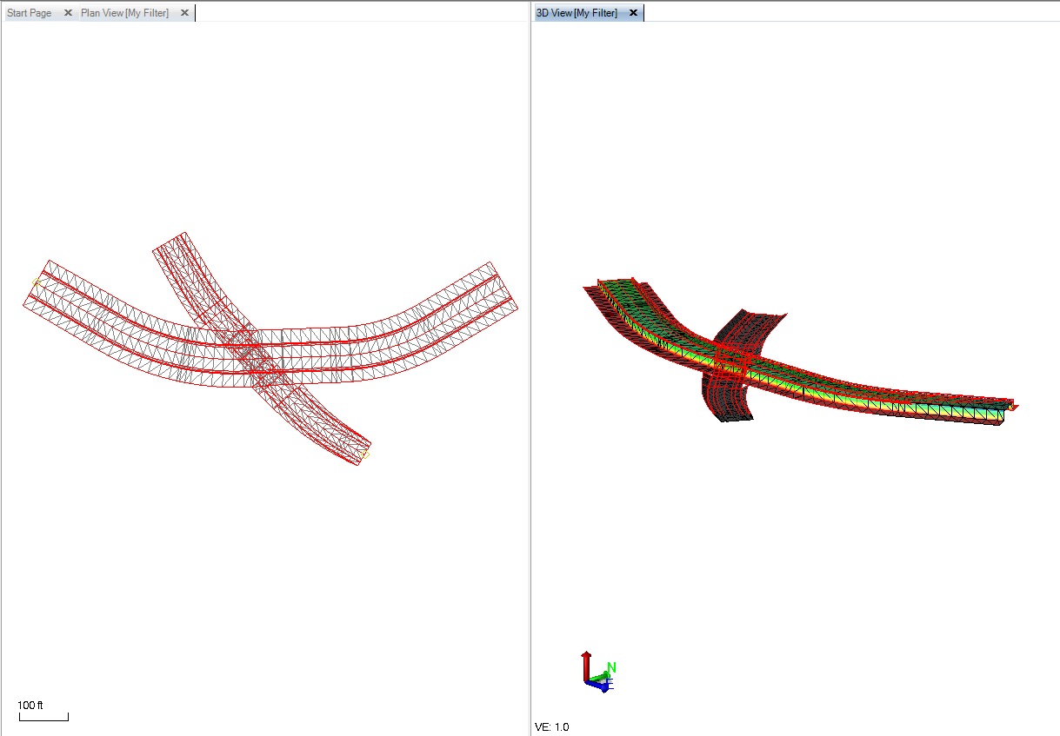
Two boundaries were created using linework generated for the N-S road (Explode the N-S Road) and then extend the edge lines around the limits of the E and W sections of the E-W Road as shown below.
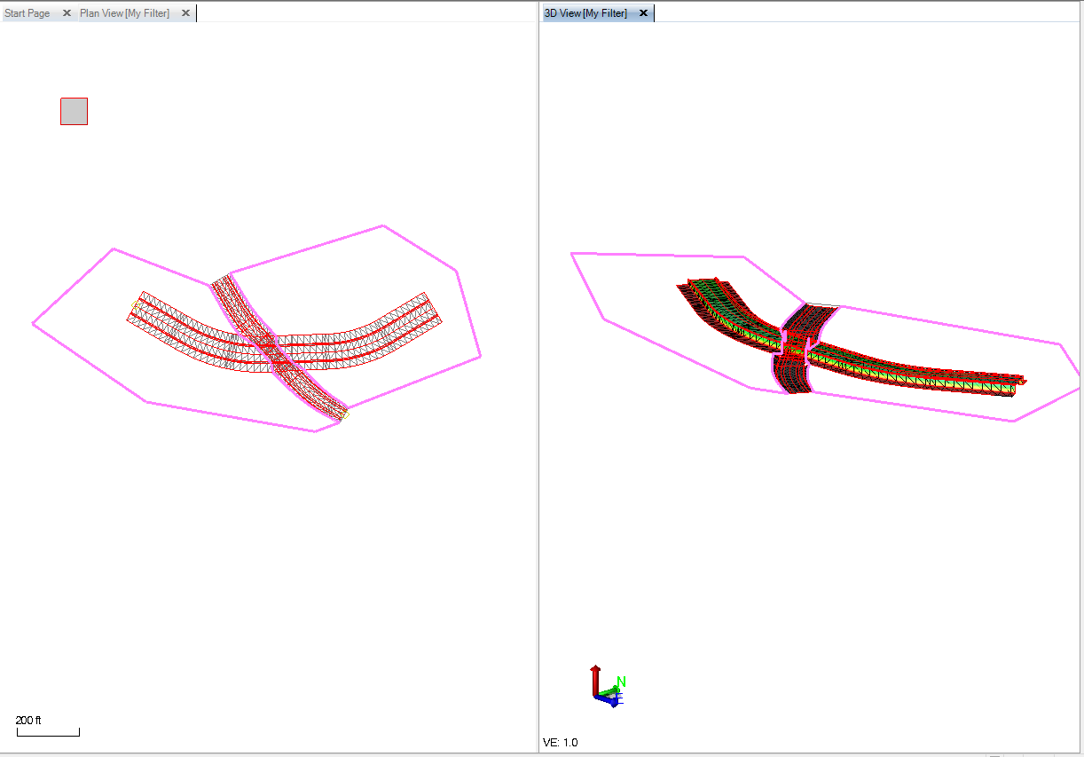
When the two boundary lines are added to the E-W Corridor Surface Model, you can see that the E-W road is truncated at the bridge as required. Note that the N-S road is intersecting the E-W road at an angle other than 90 degrees, and this application of the Boundaries, truncates the model as desired at an angle.
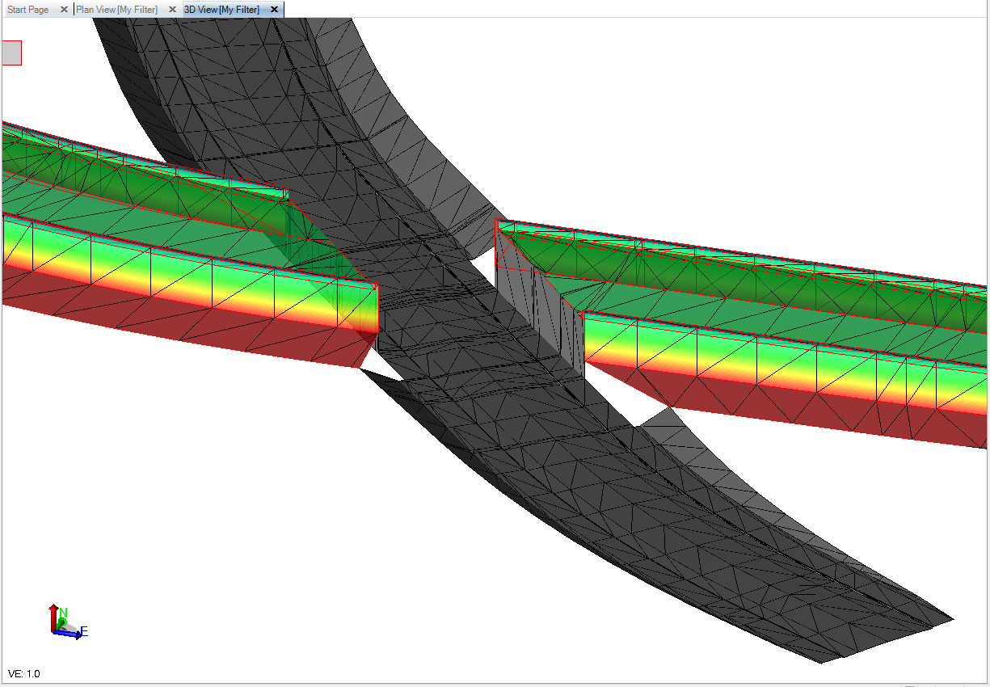
The same boundaries can be applied to the Corridor Earthwork report to compute the volumes for the East and West sections of the corridor project.

Using Tables in Corridor Template Instructions
- When you create an “Offset” component of a Template instruction using a Table, the nodes of the table will automatically create “section drops” in the corridor surface model.
- When you create an “offset” component of a Template using a 2D line, the nodes of the 2D line will not automatically create “section drops” in the corridor surface model. If however you add the 2D line to an offset table, it will then create “section drops” in the corridor surface model.
- When you create an “Elevation” or “Delta Elevation” component of a Template instruction using a Table, the nodes of the table will not automatically create “section drops” in the corridor surface model. If you want section drops where you are changing the elevation of the instruction, you must also create horizontal offset locations at those same stations, even if the offset isn’t changing.
- When entering values into tables for template instructions, if you place a ? in any of the offset, slope or elevation fields, it will stop the instruction from forming an element after that specified station. For example the following pairs of data will pause the EOP string at station 100 and restart it at station 125.

Station Offset Code
0 12 EOPR
100 ? EOPR
125 12 EOPR

Note that the EOPR element will be created from Station 125 to the end of the corridor without any additional information in the table.

If you want to create a Taper that starts and stops around a widened section of pavement, e.g. a turnout lane for an exit off a highway, the following table would be required. The example also has a gap in the turnout lane for the exit itself.

Station Offset Code
100 0 TOR
150 12 TOR
225 ? TOR
250 12 TOR
325 12 TOR
375 0 TOR
375.01 ? TOR

Note when the widening tapers at the up station end from 12 to 0, because the width is changing from 12 to 0, you have to add an extra node into the Table to terminate the widening at a point 0.01 beyond the end of the taper.

Computing Surface Areas in a Corridor Model
We are often asked how a corridor model can be used to compute the surface areas of certain elements of the corridor model e.g. for the Face areas of MSE Walls or for the surface areas of a corridor pavement subgrade surface that get paid based on graded area versus volume of material. This can be easily achieved in a Corridor Model using the Material Layers capability. Follow these steps
- If for example you are trying to compute the face area of an MSE Wall(s) for a Corridor. First create a Material Layer called MSE Wall Faces.
- Within the Corridor Template, as you create instructions, the instruction will ask you for which Material Layer(s) you want the instruction element to belong to e.g. Finish or Over-Excavation etc. For each of the elements that will count to the MSE Wall face area, add the MSE Wall Faces material layer in addition to any other Material Layer (e.g. Finish).
- When you run the Corridor Earthwork Report the MSE Wall Face Areas will be reported in columns of the Excel Report.
- If you change the property of the Corridor Surface Model so that the Material Layer MSE Wall Faces is selected, then you can run a Surface Information report on the surface model to compute the surface areas of the MSE Walls.

Computing Multiple Volume Areas within a Corridor Surface Model
Many people miss this capability of a Corridor Model. The Corridor Model has three main components to most users as follows
- You can reference the corridor to an Original Ground model.
- You can define the “Finish” Material Layer for the Corridor. If no other material layers are defined, the corridor model will compute a Cut / Fill to the referenced Original Ground surface.
  - Cut is where the Finish material layer is below Original Ground.
  - Fill is where the Finish material layer is above the Original Ground.
- You can define subgrade Material Layers e.g. for Pavement surfaces (Asphalt, Base Course, Sub Base Course etc.). These effectively lower the Finished Grade surface, thereby increasing Cut quantity and reducing Fill Quantity in the corridor earthworks. The bottom of subgrade definition effectively becomes another reference surface in the computations.
- It is this point that people often miss. You can also define any number of additional Material Layers for the purposes of extending construction models. For example you can add a Material Layer called Over-Excavation and then define elements that lie below Finished Grade that need over-excavation and backfill as part of the construction process e.g. at the base of MSE Walls, you may need to offset on the inside of the wall by an amount 0.8x the height of the MSE Wall, and then slope at e.g. 2:1 towards the centerline. Above the Layback and slope you have Structural Fill. Below you will have normal or non-structural fill. On the outside of the wall you may also have to excavate e.g. 4’ (to make room for the wall creation process and foundations) and have a tie slope to original ground at say 3:1. Above this offset and slope you also have non-structural fill. The key here is that on the outside of the wall, the “Finish” surface must also extend from where the wall crosses intercepts the Original Ground out to the tie point where the over-excavation ties to the original Ground (since the Non Structural Fill needs to fill to the Finish (Design) surface.
- In addition, through the use of Material Layers, you can model any number of “surfaces” within the corridor model that you may require for area determinations or for the creation of surface models needed for visualization or field execution.

Below is an example Project Template that was created to show how Over-Excavation can be modeled into the Corridor Model. Areas in Red that have the square hatch pattern are both Cut (Red) and Backfill (Square Pattern in Structural or Non Structural Fill). The Yellow highlighted template instruction is the last instruction in the Right Side of the Template Model. The cyan colored area and the Cyan colored square pattern is the Structural Fill for the MSE walls.

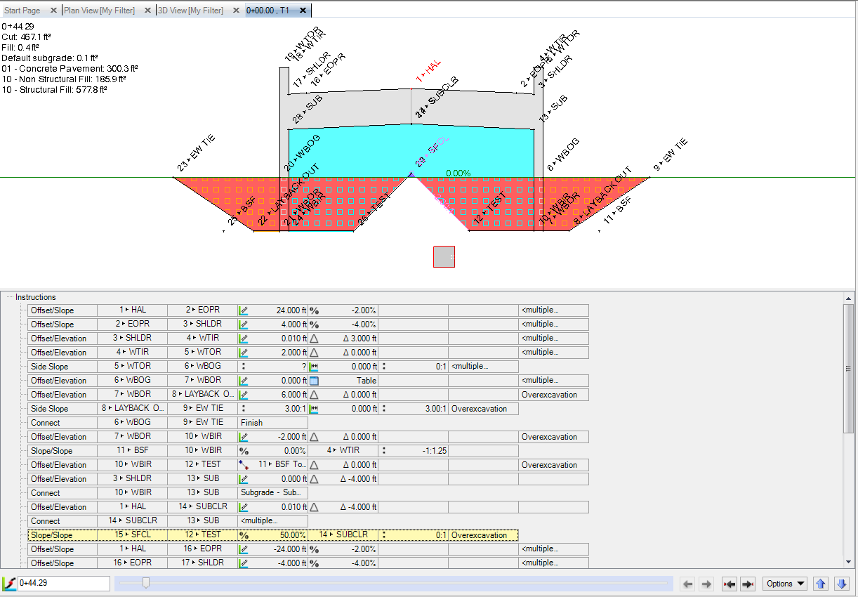

In this example you can see the points labeled 11 – BSF and 25 – BSF. These two points are “construction points” in the Template that are not assigned to Material Layers. These are interesting because of the following reasons

- In some cases you need to create a point at an offset to another point, based on some ratio of the distance between two points. In this case, the Lay Back on the inside of the MSE wall has to be 0.8x the Height of the MSE wall. In this case we used a “Slope Slope” instruction to compute the BSF points. Ideally the BSF points would have been projected toward the Centerline from the top of the MSE wall, however sometimes the direction of calculation is forced away from the centerline. So in this case we used a slope from the Top Outside corner of the MSE Wall at 0.8:1 and a slope from the point at the outside base of the retaining wall at 1:0 to compute the BSF point.
- The next instruction is an Offset Elevation instruction where the Offset is computed using the Node to Node method, and then selecting the BSF Node and the Outside Base of Retaining Wall node as the second node. That sets the offset distance to be a negative or towards the centerline direction for the distance between the two nodes. The instruction after that is a 2:1 Slope to tie at the centerline of the bridge – the two sides of the MSE embankment tie in this case at the centerline.
- You can also see that the points along the base of the Red cut area have all been tagged as Over-Excavation Material Layer, however the Material above each element differs from Structural Fill (inside the MSE Embankment) to Concrete (For the MSE Wall itself) and Non-Structural Fill for the backfill outside the MSE walls. In this way we can extract the Over-Excavation Surface and the different materials required to create the fills in the model.

How to Create Linework from Corridor Models
When you are building corridor models, especially when building out Intersections, underpasses etc. it is often helpful to generate 3D linework for the “main corridors” that you can use to compute the locations required for the placement of offset or elevation table locations etc. You can generate linework at any time by “Exploding” the Corridor Surface Model. This process creates the linework from the current state of the corridor model. It does not destroy or change the Corridor Model or the derived Corridor Surface Model(s).
- Note that the linework created is not linked back to the Corridor Model, i.e. if the Corridor Model changes, the linework will not update to reflect the changes made to the corridor model.
- It is good practice to delete the linework once you have computed what you need to compute, and regenerate it again at a later stage if you need it again, because as you evolve a corridor model, the linework that can be generated will also change.

Conditional Instructions
We are often asked what the difference is between an IF, Else and Else IF statement when working with Conditional Instructions.
In all cases we are asking a Question that has a Yes or No (True or False) response. That Yes / No or True / False response can be tested against a range of values or by specific questions such as Is the point Above this Surface? The answer can be Yes or No.
So when using conditions, the main question is
- Am I testing a single question where if the answer is Yes then do XXX and if the answer is No do YYY instead. In this case you use an IF to ask the question and if the answer is Yes, the template instructions after the IF will be executed. If the answer is No, then the template instructions after an ELSE statement will be executed instead. ELSE is basically the only alternative to the IF option.
  - IF
    - Template Instructions execute if the IF statement is answered True / Yes
  - ELSE (always gets triggered if the prior IF statement is answered False / No)
    - Template Instructions execute if the IF statement is answered False / No
  - END IF

- Am I testing multiple scenarios (i.e. more than a singular Yes / No scenario) where we ask a first question using the IF statement and get the Yes or No response, if Yes we execute the template instructions associated with the IF statement and if NO we move onto the next question which is defined using an ELSE IF statement. You can have as many ELSE IF statements after a singular IF statement. Where each ELSE IF is testing a different scenario. The testing goes on, jumping to the next ELSE IF in sequence until it gets a positive response. At the “True” point the corridor Template instructions associated with the ELSE IF that passed get executed. Now that you have had a Yes or True response, all other ELSE IF statements in that sequence get ignored and the IF test gets terminated.
  - IF
    - Template Instructions execute if the IF statement is answered True / Yes
  - ELSE IF (gets triggered if IF statement is answered False / No)
    - Template Instructions execute if the ELSE IF statement is answered True / Yes
  - ELSE IF (gets triggered if prior ELSE IF statement is answered False / No)
    - Template Instructions execute if the ELSE IF statement is answered True / Yes
  - Repeated ELSE IF statements
    - Each ELSE IF has its own template instructions
  - END IF
If no ELSE If statement passes, either the sequence terminates with no action, or the final statement can be an ELSE statement which executes if all of the IF and ELSE IF statements prior to it have failed. This is a “catch all” that creates something in the event that all the other tests fail.

Notes:
If Statements can also be nested to handle the most complex scenarios, these are however quite rare in occurrence or need.

The main challenge for the user is to come up with the specific test that needs to be carried out to determine the conditions of each alternative to be considered.

Typical Use Cases of Conditions
- Testing to see whether a previously constructed node lies in Cut or Fill condition to determine whether to apply the Cut or Fill conditional set of instructions (where a simple slope tie is not sufficient to meet the need)
- Testing to see whether a previously constructed node is in a specific depth of Cut or Fill, through which an appropriate side slope will be defined based on the depth or elevation at which the hinge point lies in relation to the target surface
- Testing to see whether a previously constructed node is in Cut and in a specific type of material that may need a different treatment to the normal situation. E.g. If in Rock then Tie to Rock Surface at 1:10, if not in Rock then Tie to Original Ground at 3:1 etc.
- Testing to see whether a Ditch with Cut Slope to Original Ground falls within the Right of Way Limits, and if it does create it and if it doesn’t create a different Ditch and Tie Slope scenario.
Notes:
In many cases it may be necessary to create a “test node” or “set of test nodes” that don’t contribute to Material Layers that can then be validated against the Test Conditions before creating the template instructions that define the surface elements tied to material layers.
Conditions can test the following main scenarios
- Is the node above a defined surface
- Is the node below a defined surface
- What is the Nodes vertical distance to a surface
- What is the nodes distance from another node
- What is the nodes vertical distance from another node
- What is the nodes horizontal distance from another node
Depending on the condition test applied, you can enter a min (>=) and max (<=) value for the Pass condition, values outside this condition test are considered a Fail / No and will force the Else or next ELSE IF statement to execute.

Using 2D Lines as an Instruction to Vary Offset / Width of Template Elements
When defining a Template instruction that has an Offset component, the offset can be defined using one or more 2D lines, and from those lines the entirety of their length or a subset of their length only. When there is only one 2D line and you want to utilize the entire length of the 2D line, you can select 2D Line as the input method, and then select the 2D line from the graphical views. If you do this however, in the current release of BC-HCE (v4.0), we do not automatically create Section Drops in the Corridor Surface Model that is created from the instructions at all the node points of the 2D line. The Corridor Model will be 100% correct, just the Corridor Surface Model is not 100% replicating the intent. Instead of selecting the 2D line as the only input, select Table and then within the Table you can select a station value and then select in place of offset at the station, the 2D line option. From here you can select a 2D line and then state that you want to use its entire length or only the portion that runs to a second station value and entered with an Offset value of “?”. This stops the use of the 2D line at that station. You can then specify another station and another 2D Line and repeat the process as many times as required to produce the corridor model that you require. When 2D lines are entered in Tables, every node in the 2D line will create a Section Drop in the output Corridor Surface Model.

